**Internship Task 1**

Task1.Threetier Web application using Terraform and AWS.

* **Presentation Layer**: HTML/CSS/JS frontend, optionally hosted on S3 or served through Flask on EC2
* **Application Layer**: Flask REST API running on EC2
* **Data Layer**: MySQL database on Amazon RDS

1) VS Code workspace showing the frontend folder structure and index.html code of the Todo application.

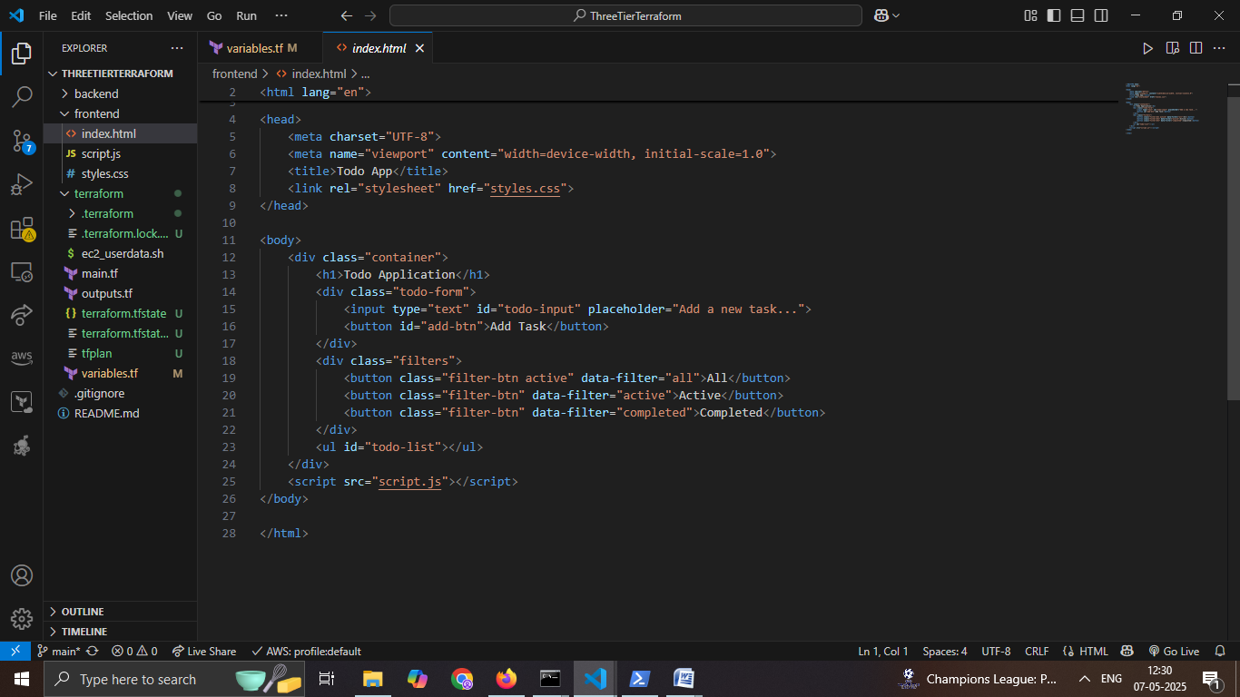

2) Backend code displayed in VS Code, showing Flask REST API implementation in app.py, including route definitions and request handling.

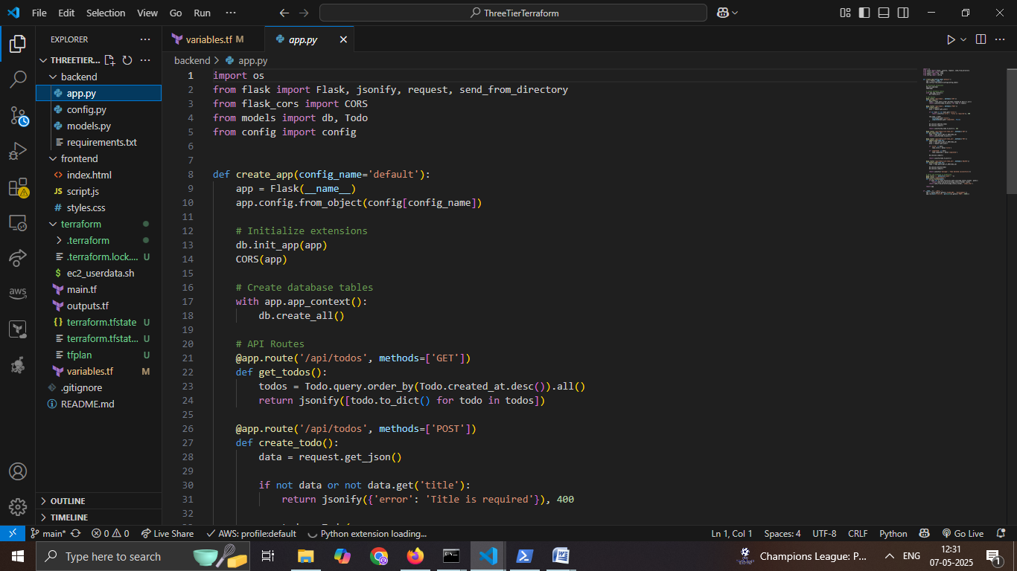

3) SQL Alchemy ORM model for the Todo application shown in models.py, defining the schema for storing tasks in the RDS MySQL database.

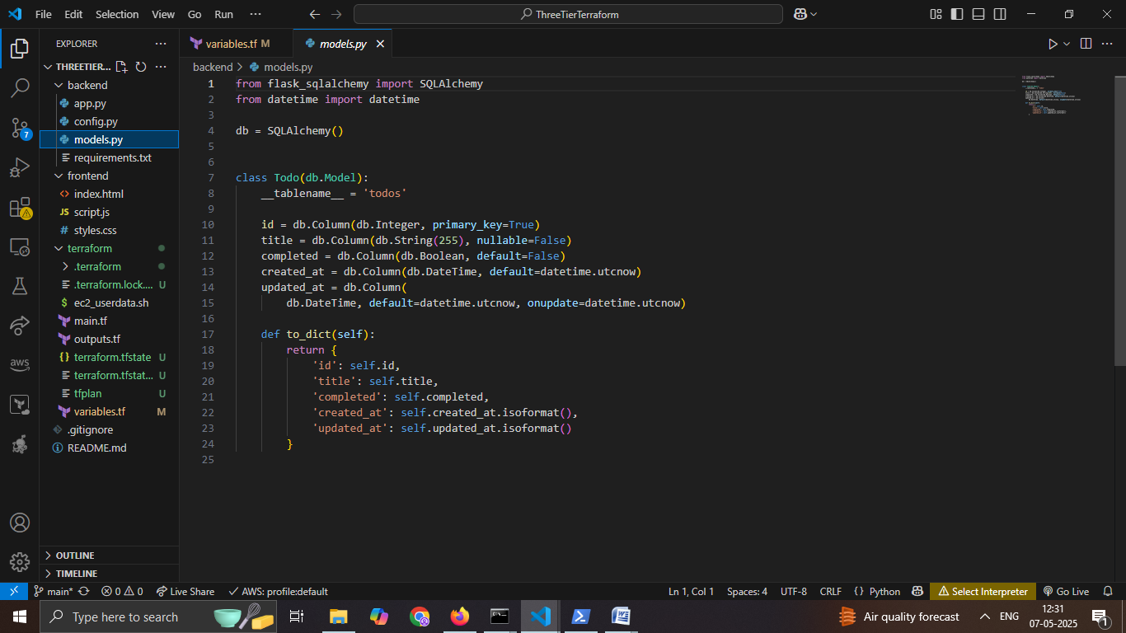

4) Terraform configuration code in main.tf, defining AWS infrastructure components including VPC, subnets, route tables, and internet gateway for a three-tier architecture**.**

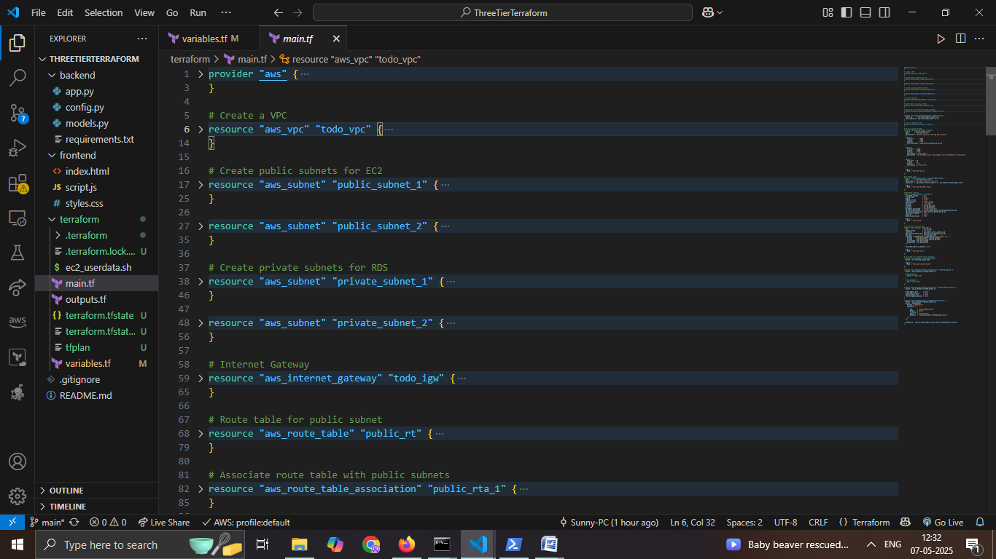

5) VS Code terminal displaying the execution of terraform init, which initializes the working directory and downloads necessary provider plugins.

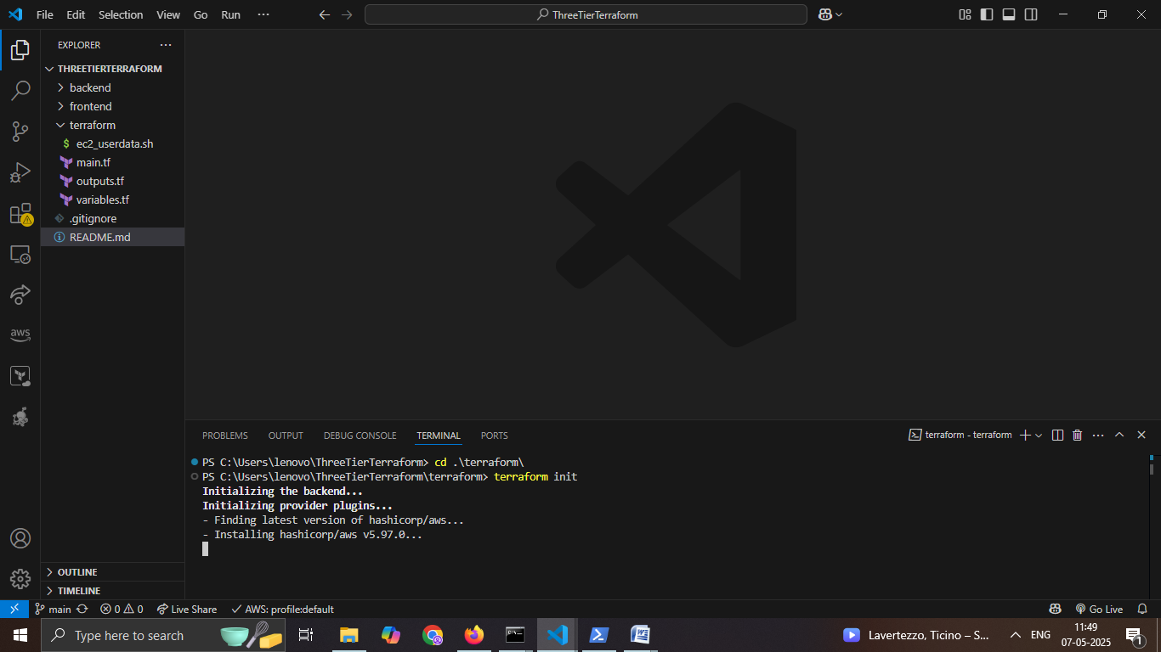

6) Terraform initialization completed successfully, indicating that the working directory is ready for further commands like terraform plan.

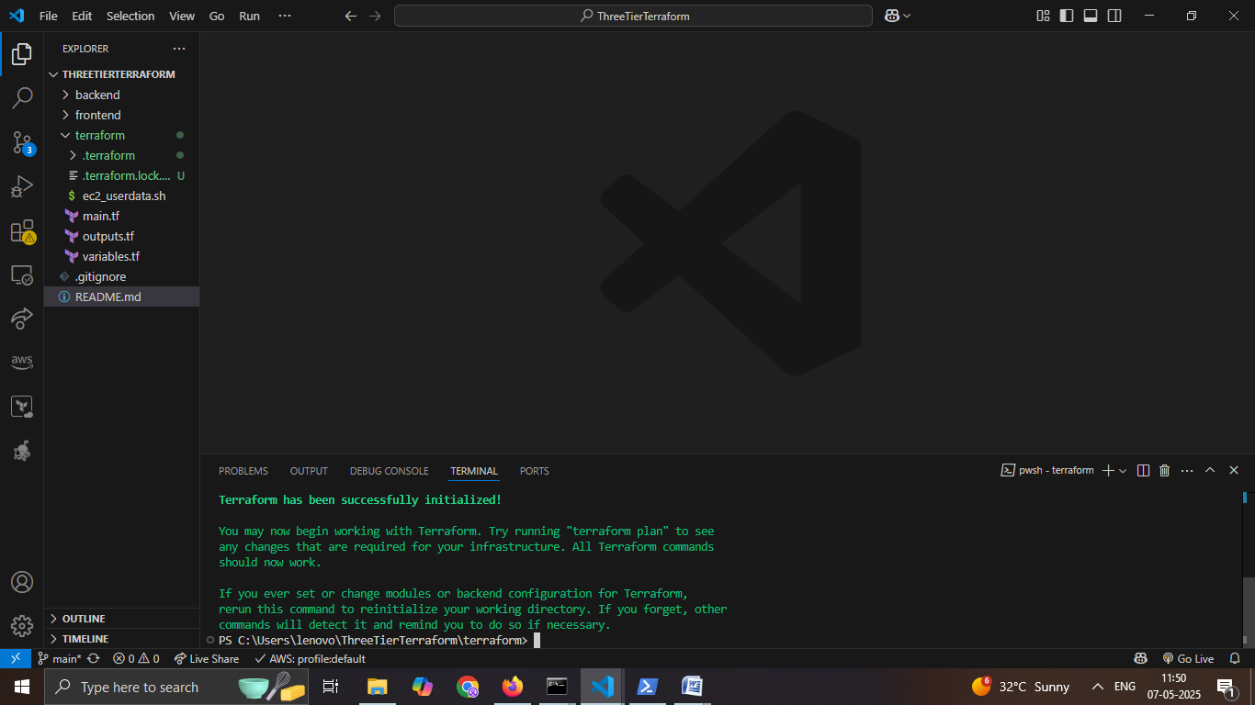

7) Running terraform plan -out=tfplan to generate and save an execution plan that outlines the changes Terraform will make to the infrastructure.

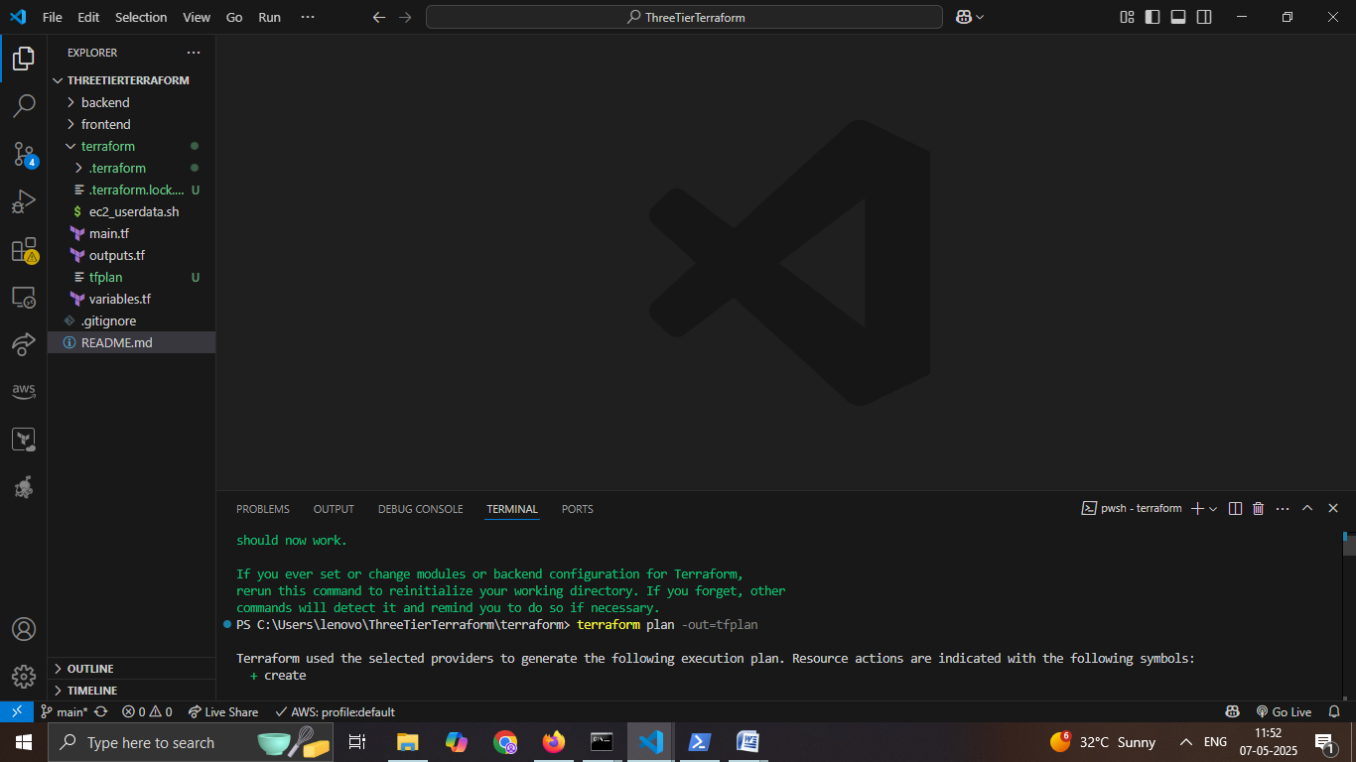

8) Successful execution of terraform plan confirming the planned infrastructure changes and saving the plan to tfplan.

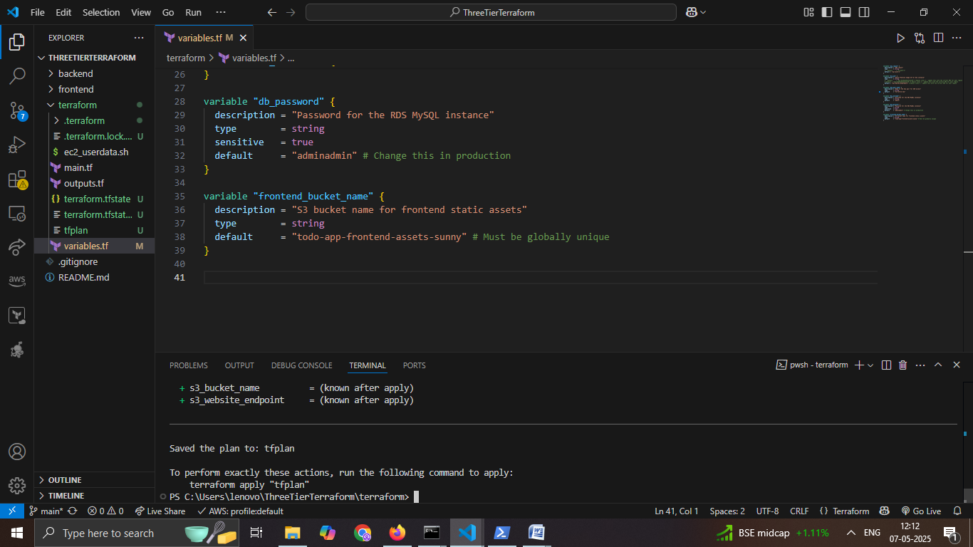

9) Running terraform apply tfplan to provision the infrastructure based on the previously generated execution plan.

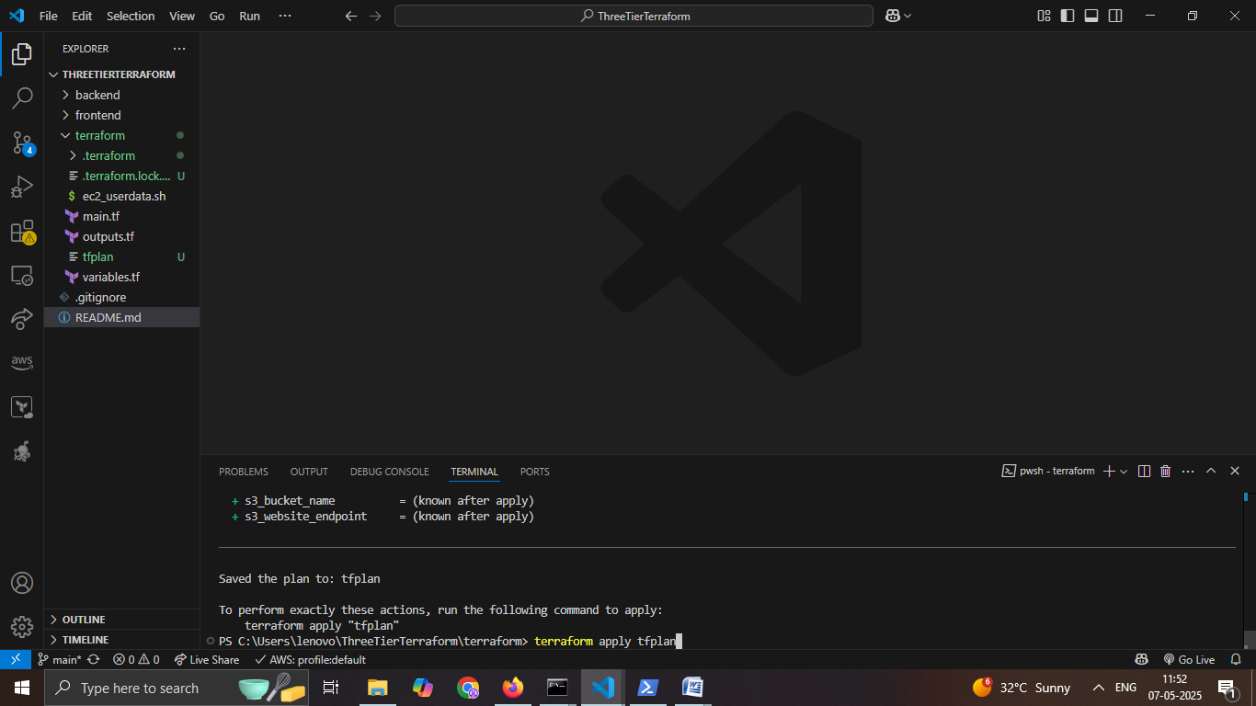

10) Successful execution of terraform apply, showing creation of VPC, subnets, and EC2 instances as defined in the Terraform configuration.

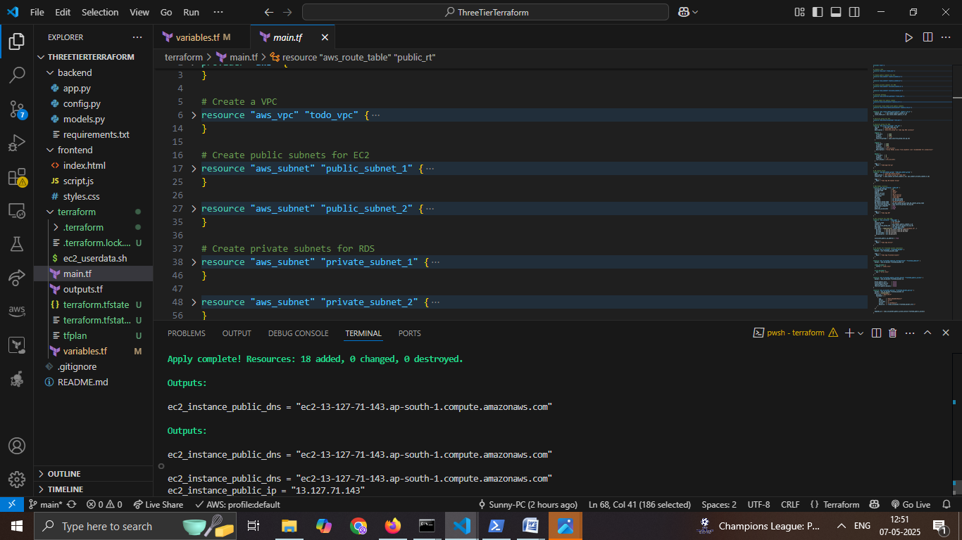

11) AWS EC2 Dashboard showing the successfully provisioned EC2 instance (Todo App Server) created via Terraform.

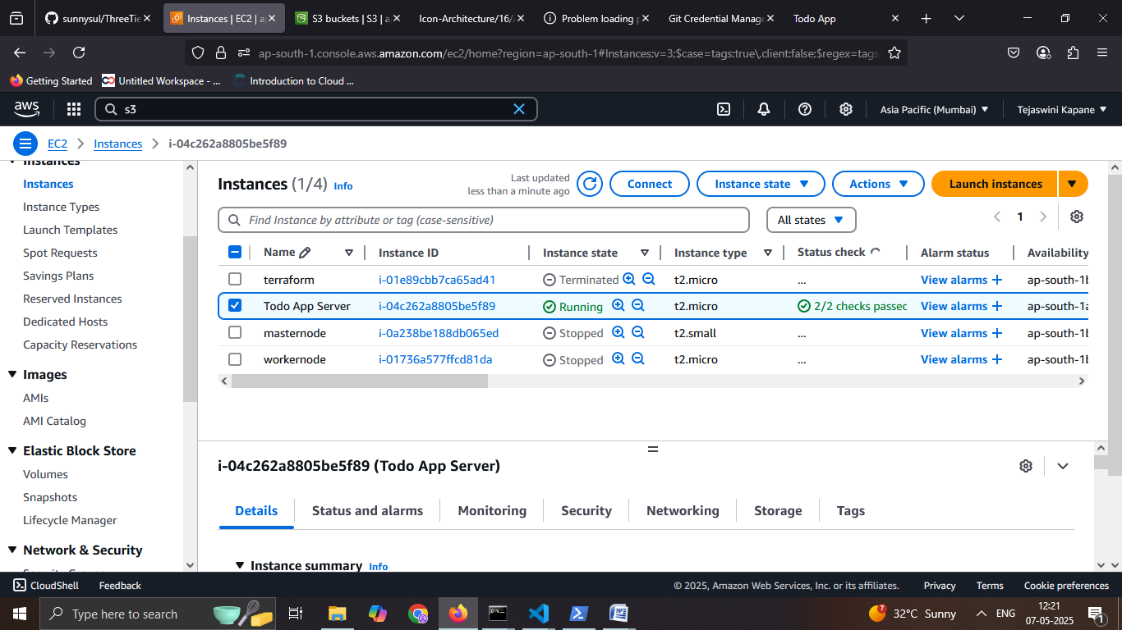

12) AWS RDS Console displaying the successfully created RDS instance (todo-app-db) using Terraform, with status marked as "Available".

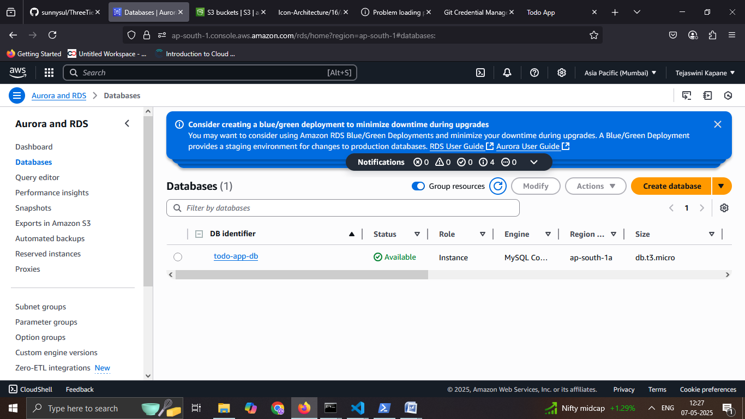

13: Successfully created S3 buckets.

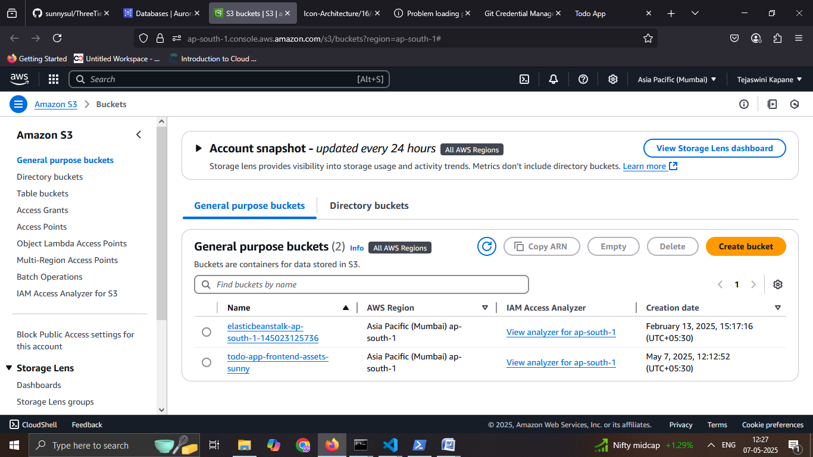

14: Successfully deployed and accessed the three-tier Todo application.

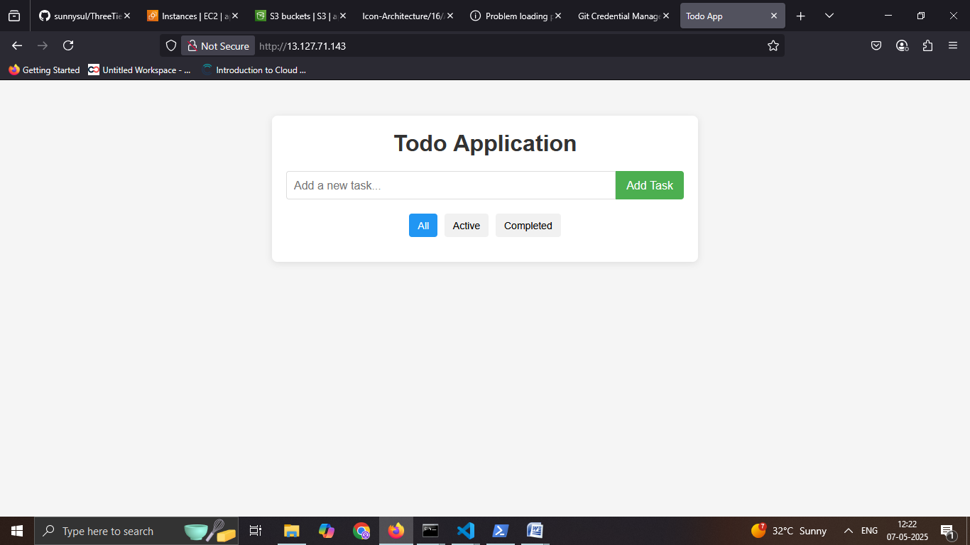

15) Added a new task in the Todo application.

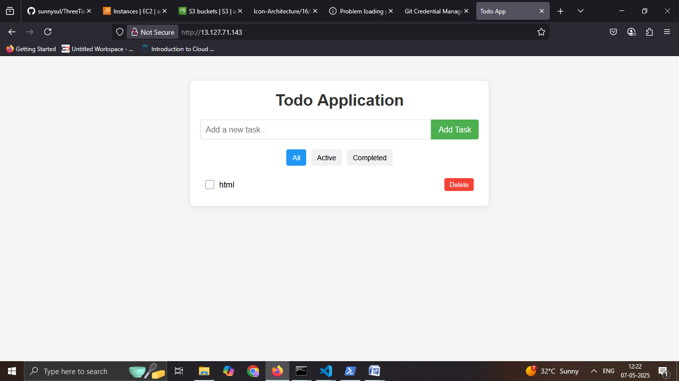

Task2) Setup your code on a Docker container using Jenkins on AWS.

1. Launched an EC2 instance and successfully connected to it using PowerShell.
2. Install the docker EC2 instance.

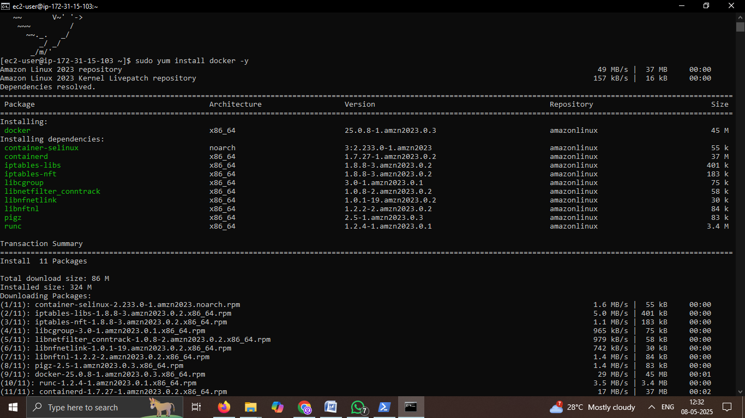

1. Handling Docker Group Permissions and Pulling Jenkins Image from Docker Hub.



4) Pulling the Jenkins Docker Image and Adding User to the Docker Group on EC2.

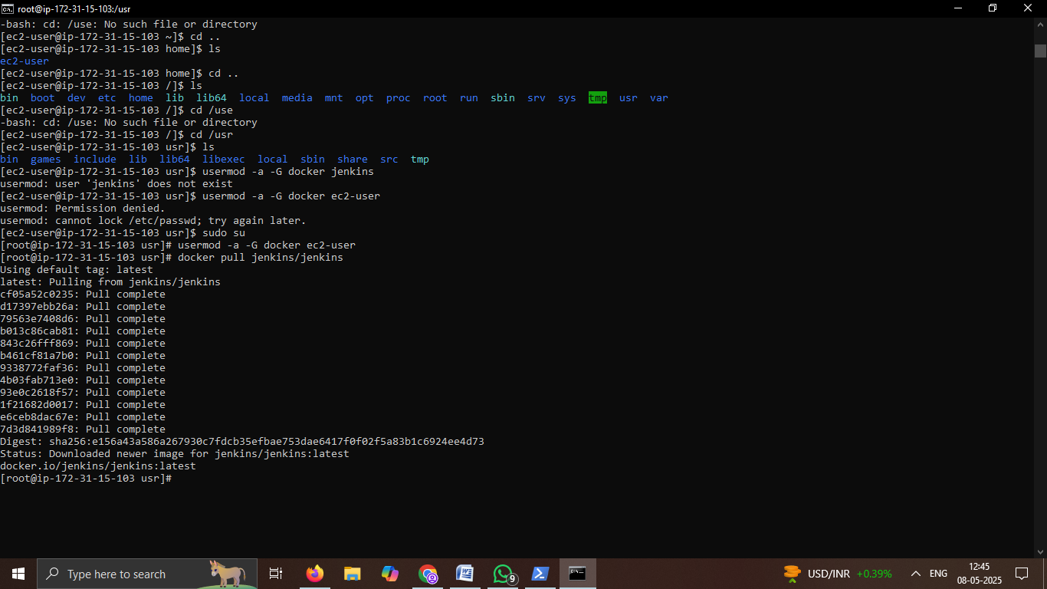

5) Verifying Docker Image Creation and Attempting to Start Jenkins Service.

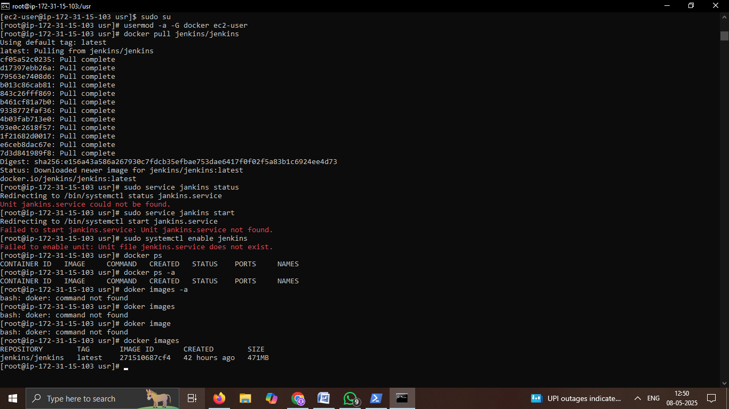

6)Jenkins Initialization Output with Admin Password for First-Time Setup.

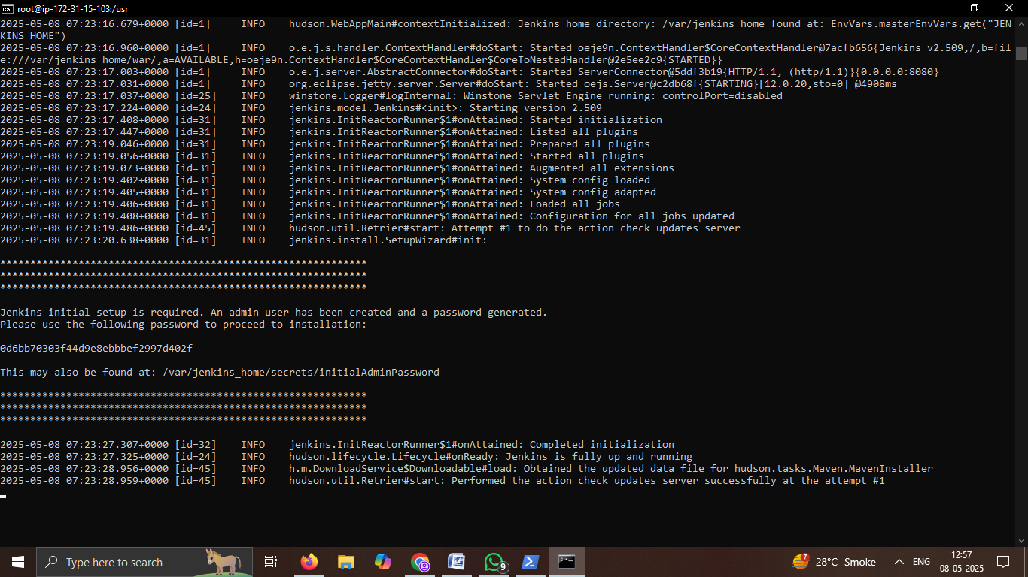

7) Jenkins Setup Wizard – Plugin Selection During Initial Configuration.

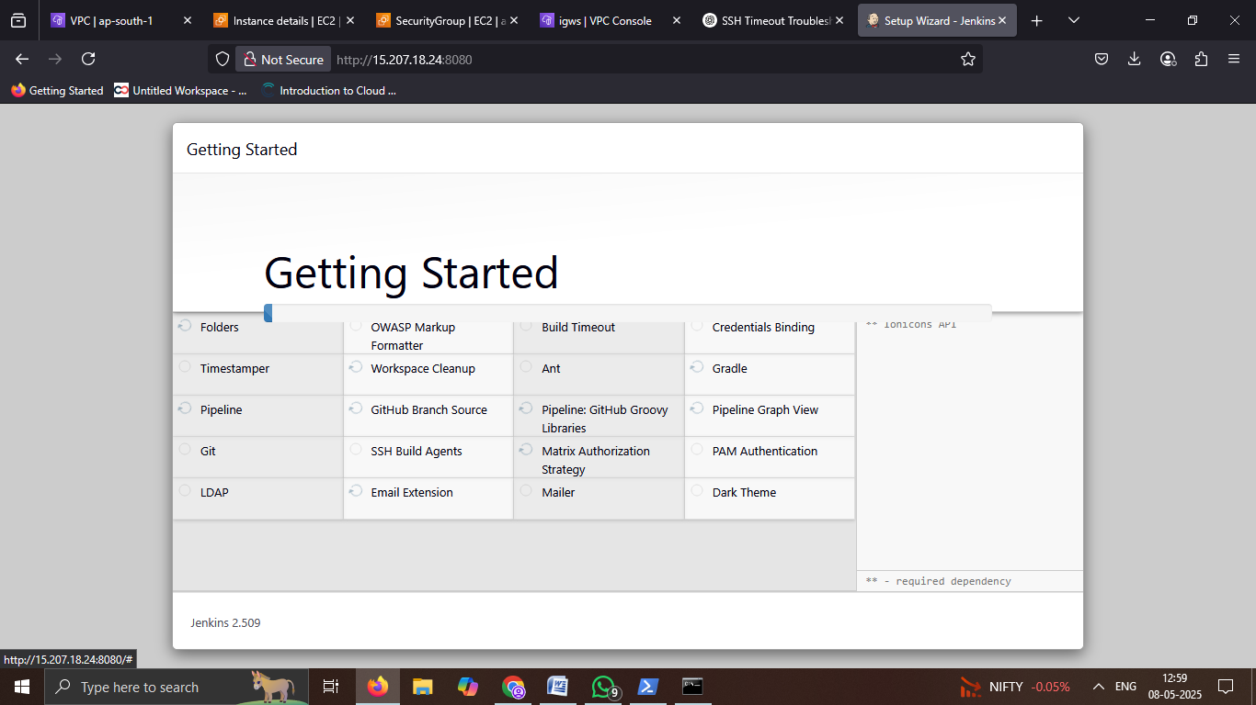

8) Creating the First Admin User in Jenkins During Initial Setup.

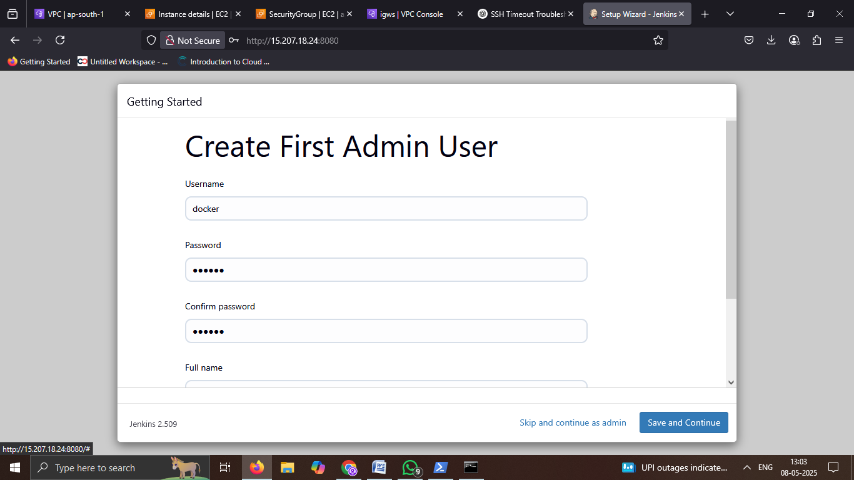

9) Configuring the Jenkins Instance URL During Initial Setup.

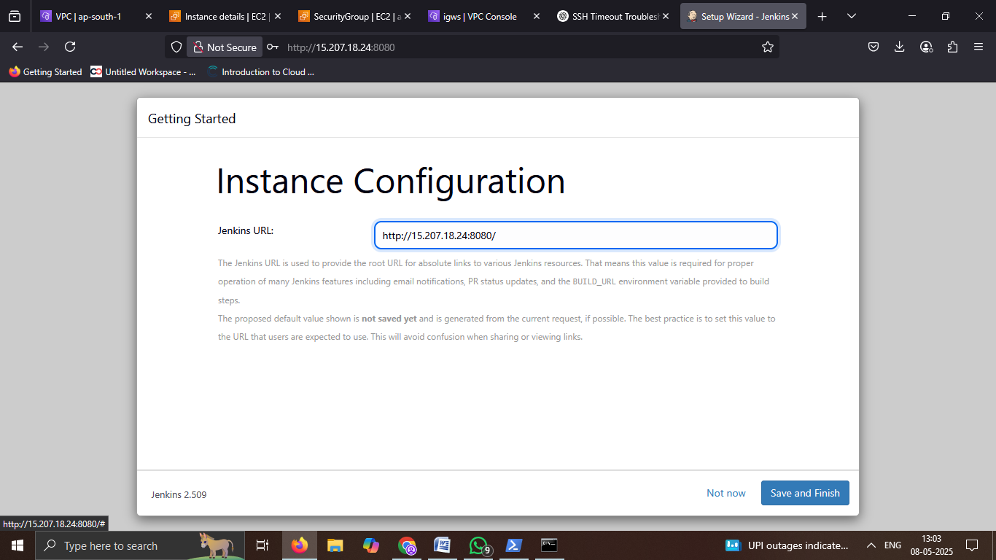

10) Jenkins Setup Complete – Ready to Start Using Jenkins.

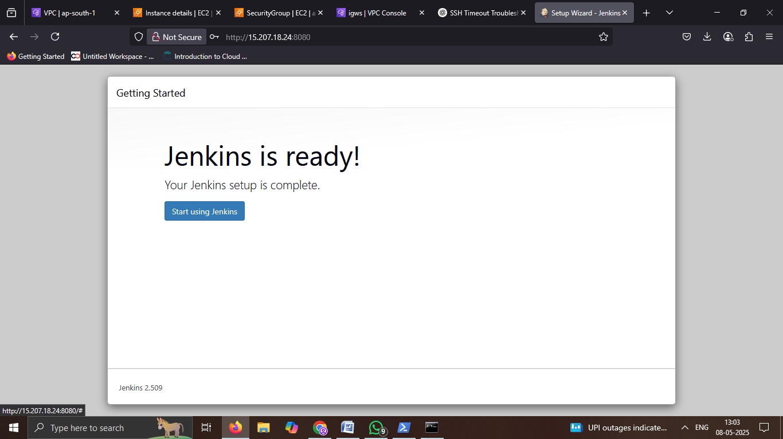

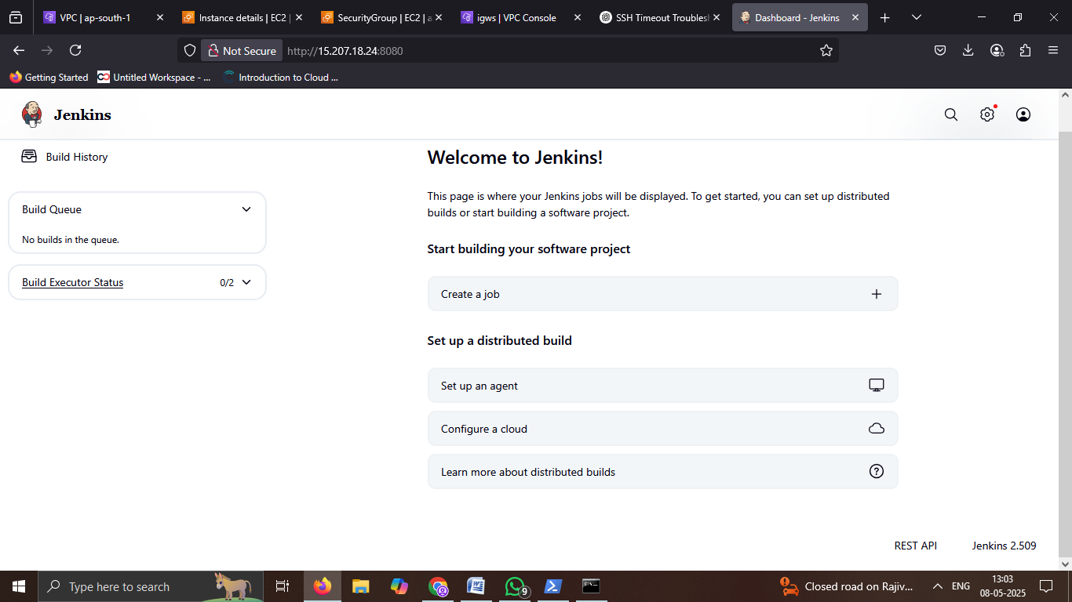

11)create mywebsite Jenkins.

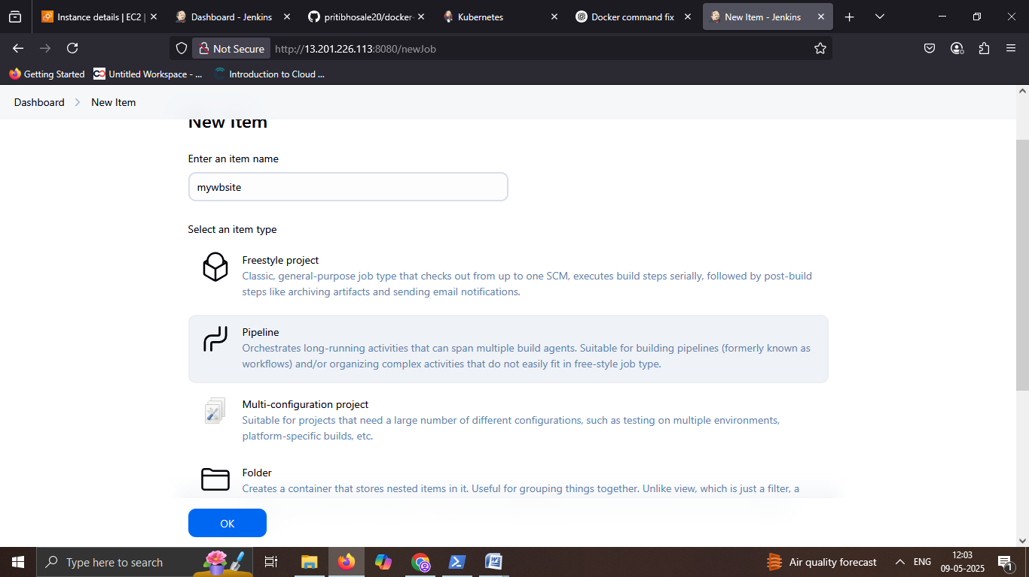

12) configure github hook trigger for GITScm polling.

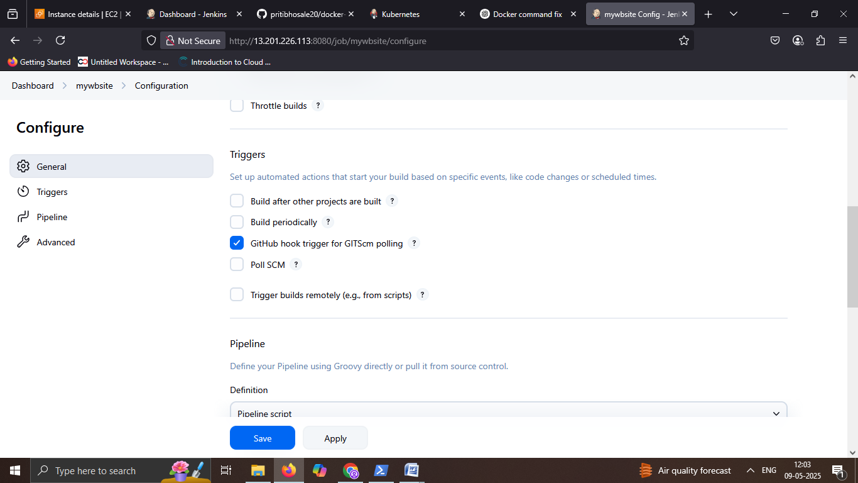

13) Adding the GitHub Repository URL in Jenkins Pipeline Configuration.

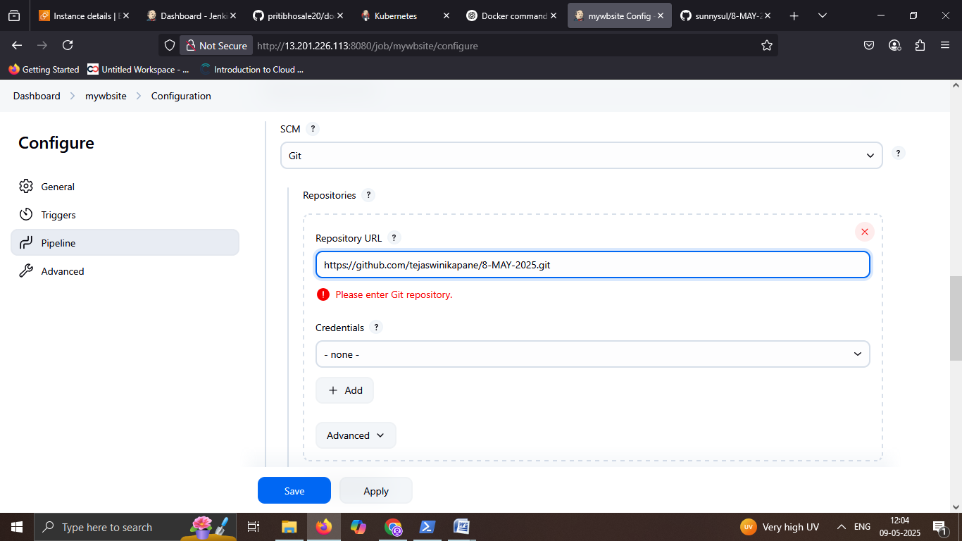

14) Jenkins Dashboard Showing Initial Build Trigger for 'mywebsite' Pipeline.

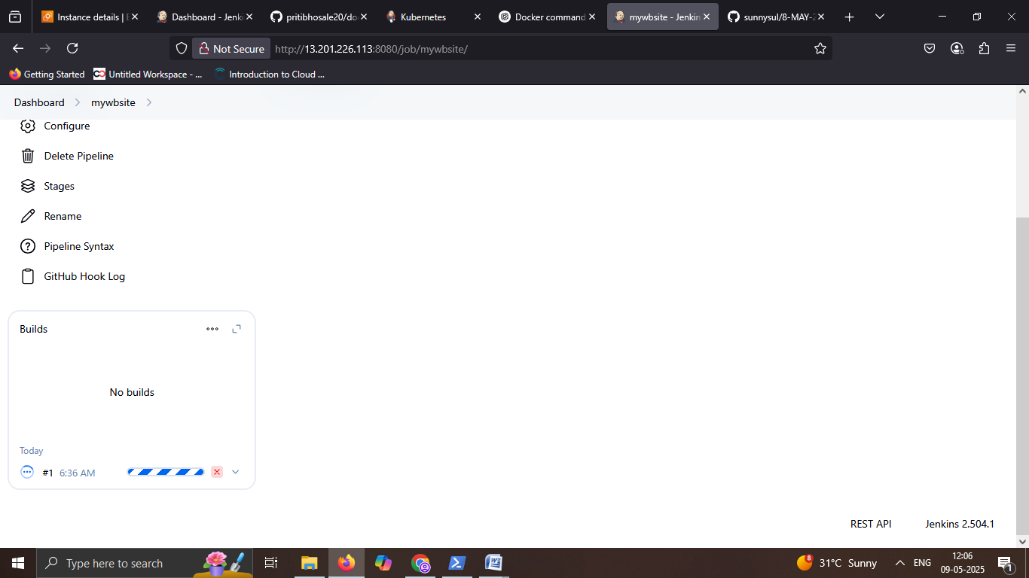

15) Jenkins Console Output Showing Successful Execution of Code Pipeline Stages.

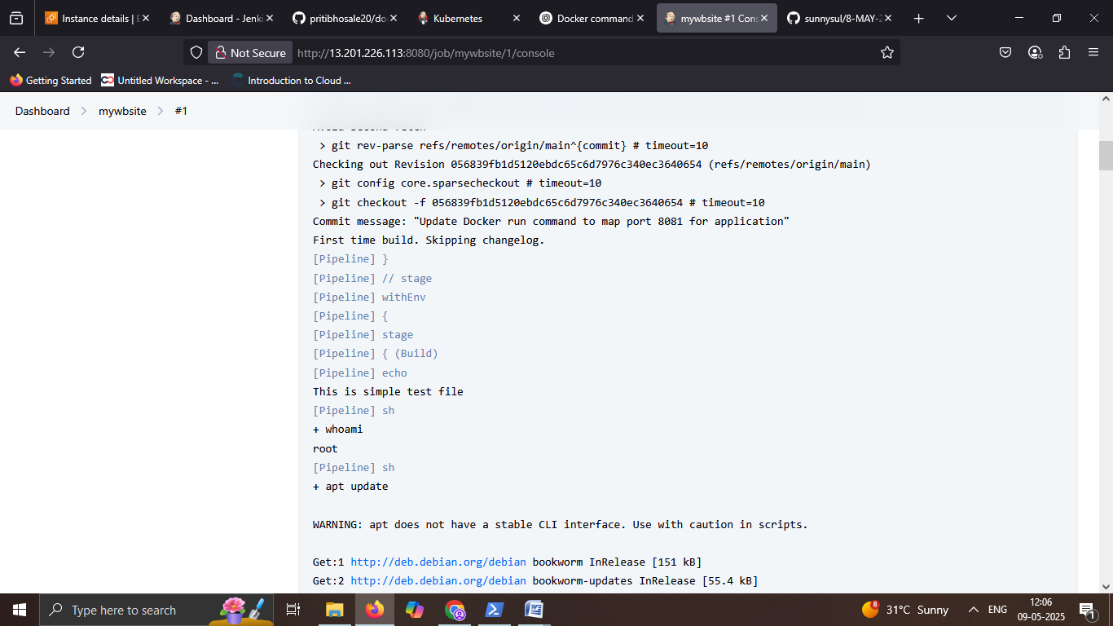

17) jenkins Pipeline Output Showing Successful Docker Image Build and Container Deployment.

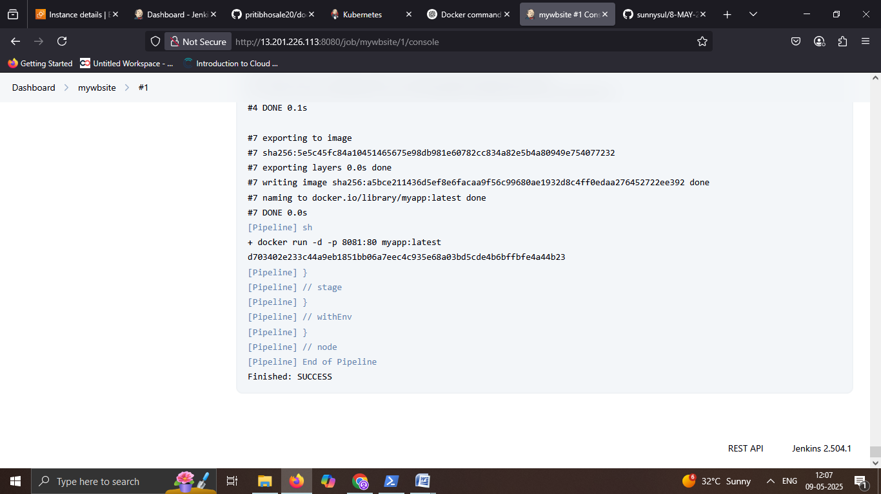

18) Adding Inbound Rule for Port 8081 in AWS Security Group to Allow External Access.

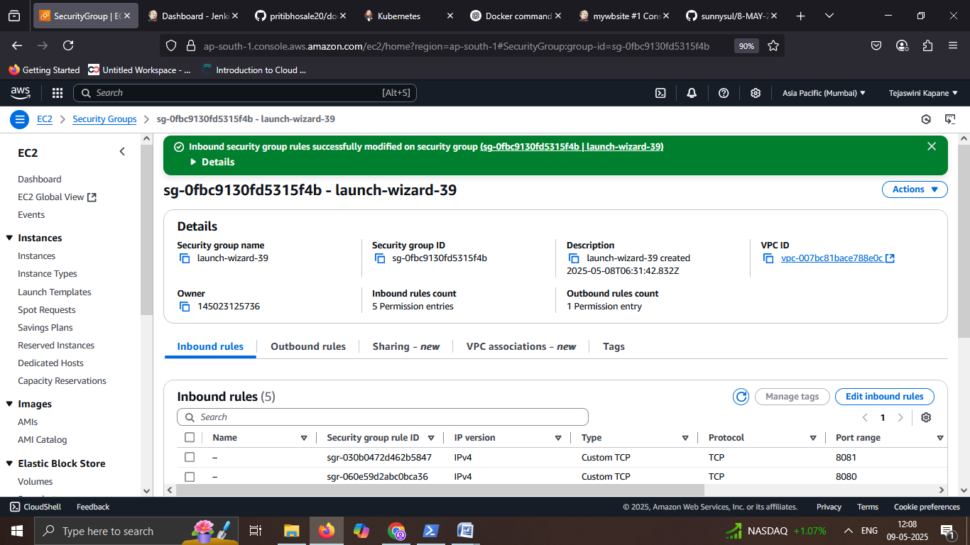

19) Web Page Successfully Deployed from Docker Container Using Jenkins on AWS.

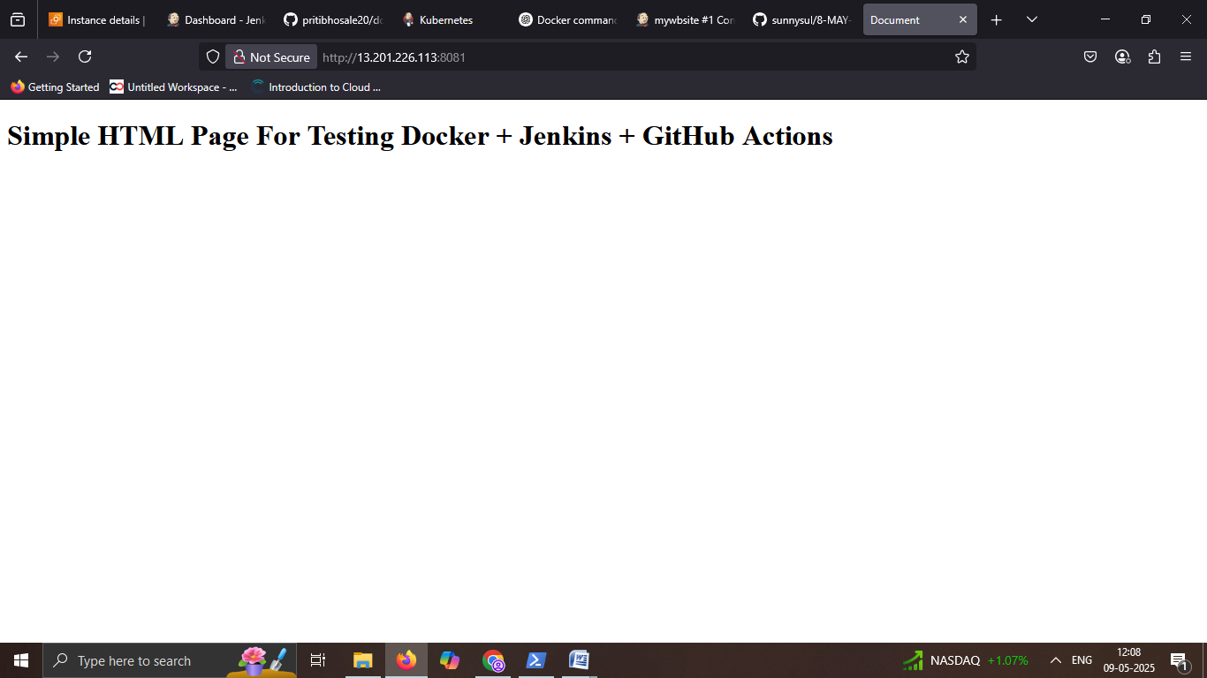

Task 3) How to install Prometheus and Grafana on you cluster using Terraform and helm.

1. All source code can be found at the following link.

<https://github.com/Tkapane3200/PG-terraform-using-helm.git>

i)Initialize Terraform.

Terraform init.

ii) Review the execution plan.

Terraform plan.

iii) Apply the changes.

Terraform apply.

2) Terraform init.

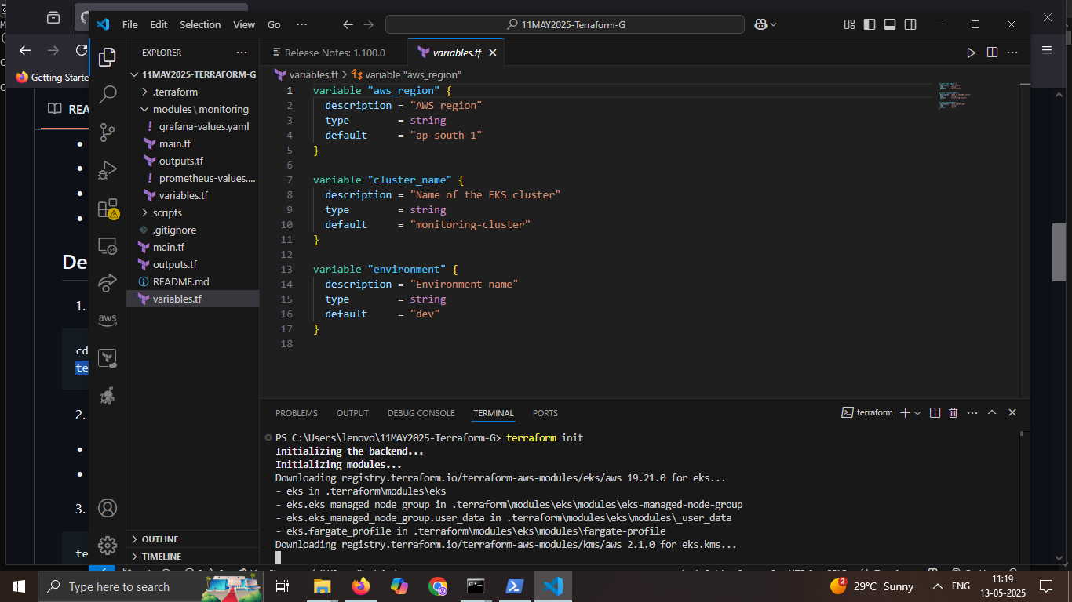

3) Generate the execution plan and save it to a file.

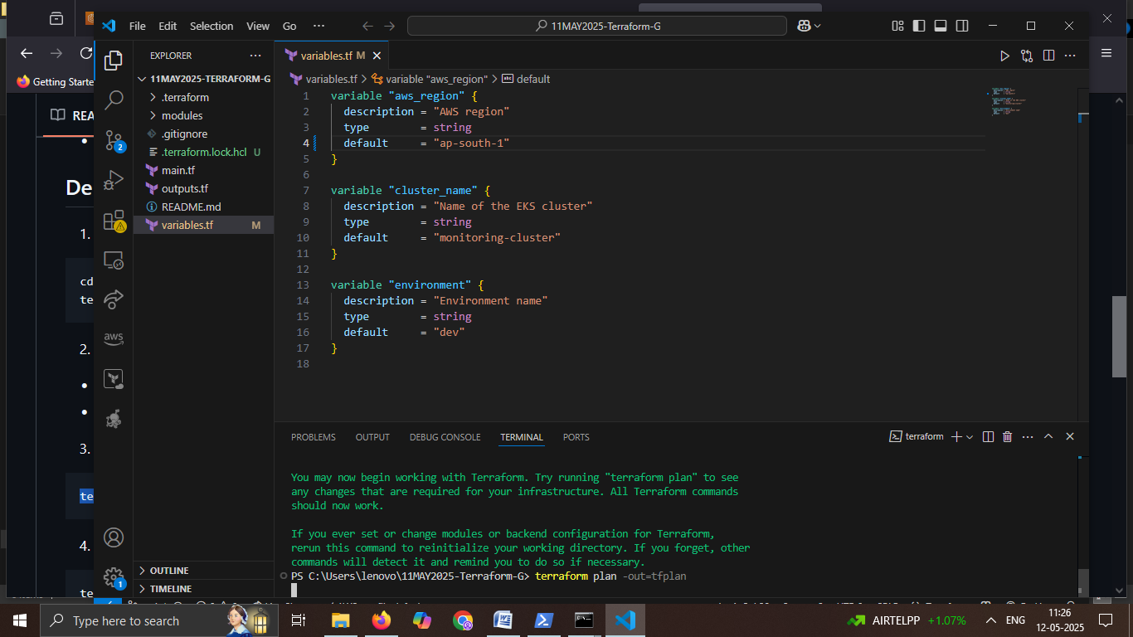

4) Apply the saved execution plan.

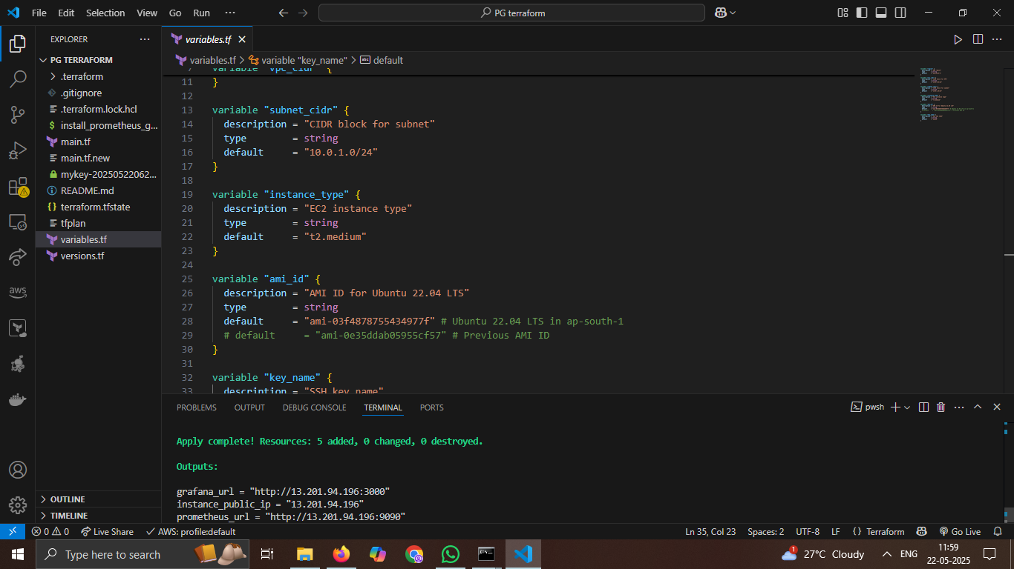

5) EC2 instances running successfully.

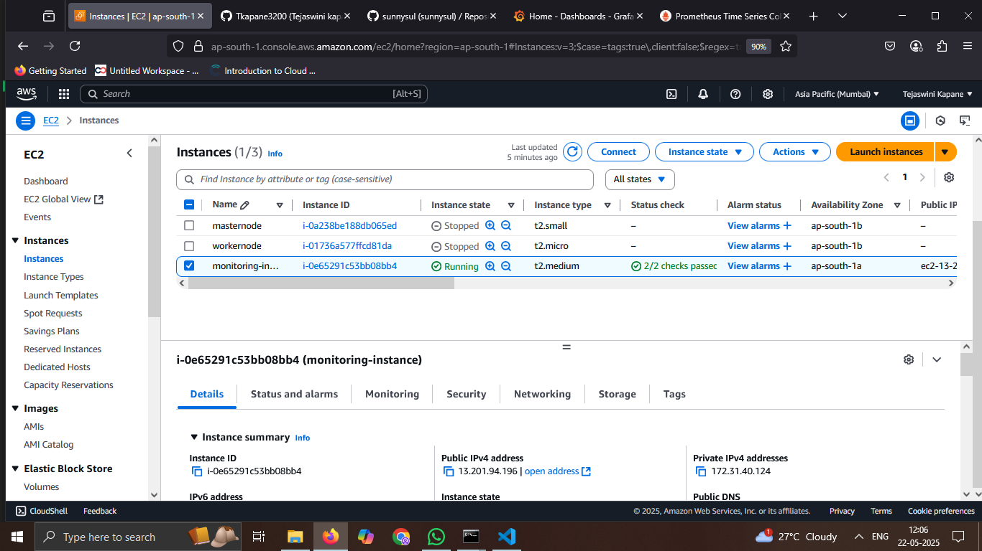

6) Prometheus application is running and displaying collected metrics.

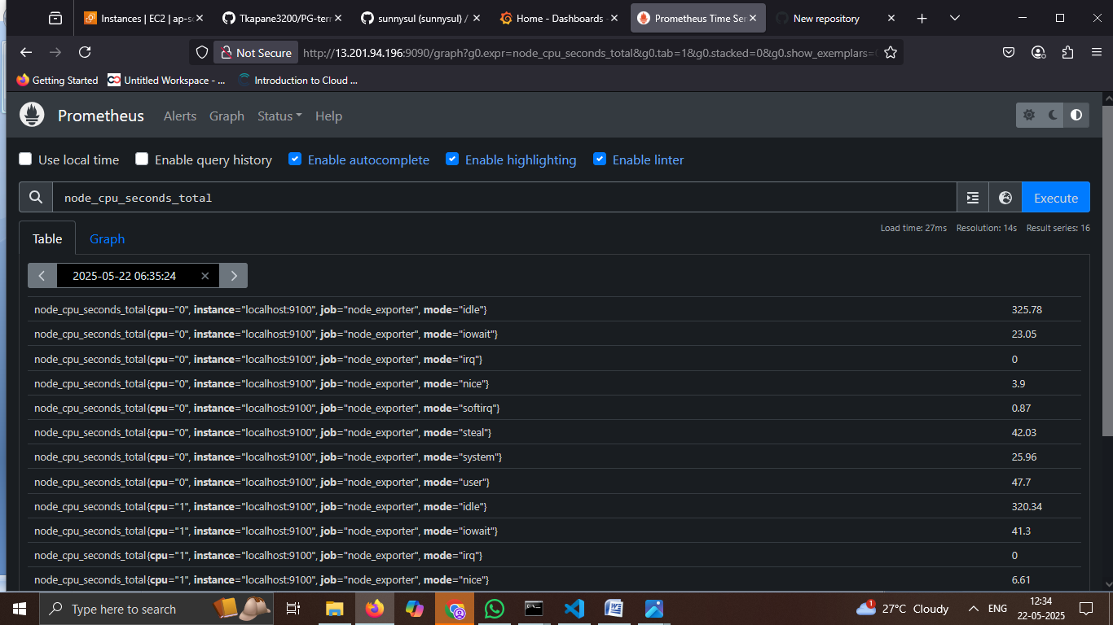

7) Prometheus interface showing query execution with no data results.

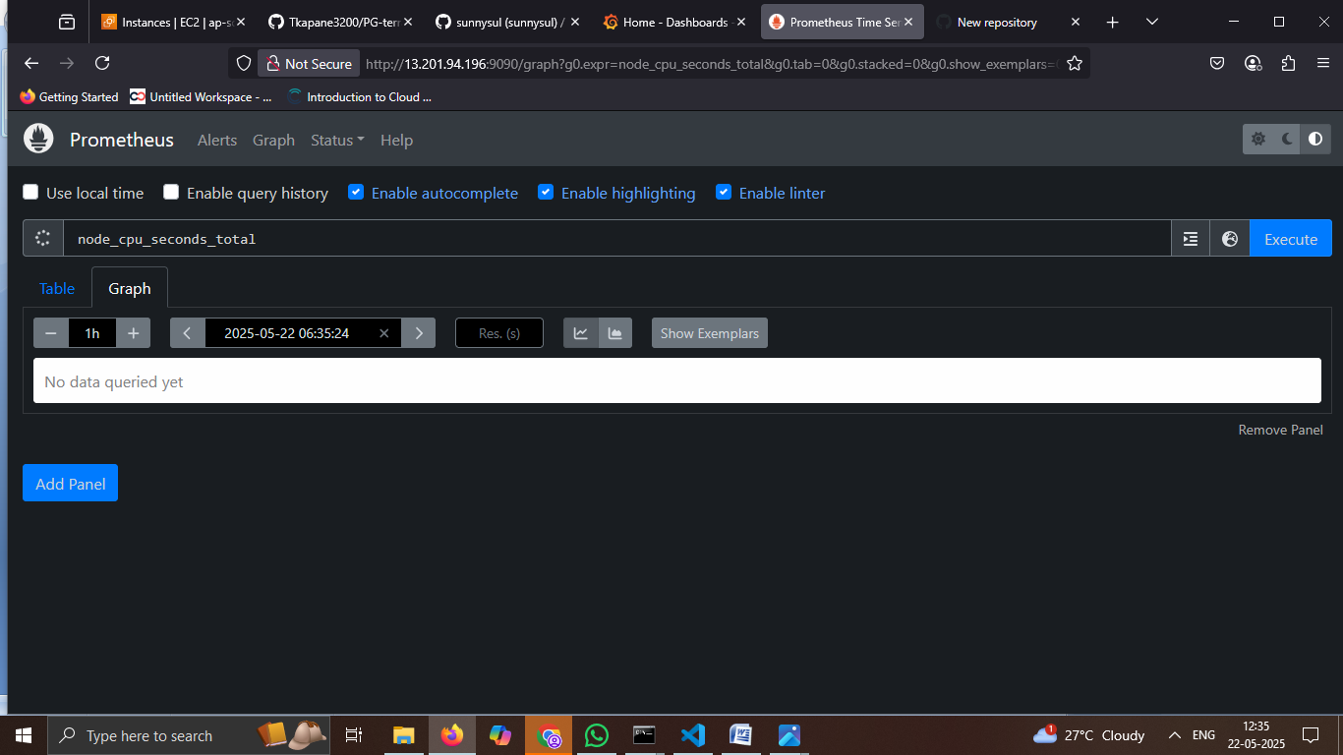

8) Grafana application is running and displaying the initial dashboard setup screen.

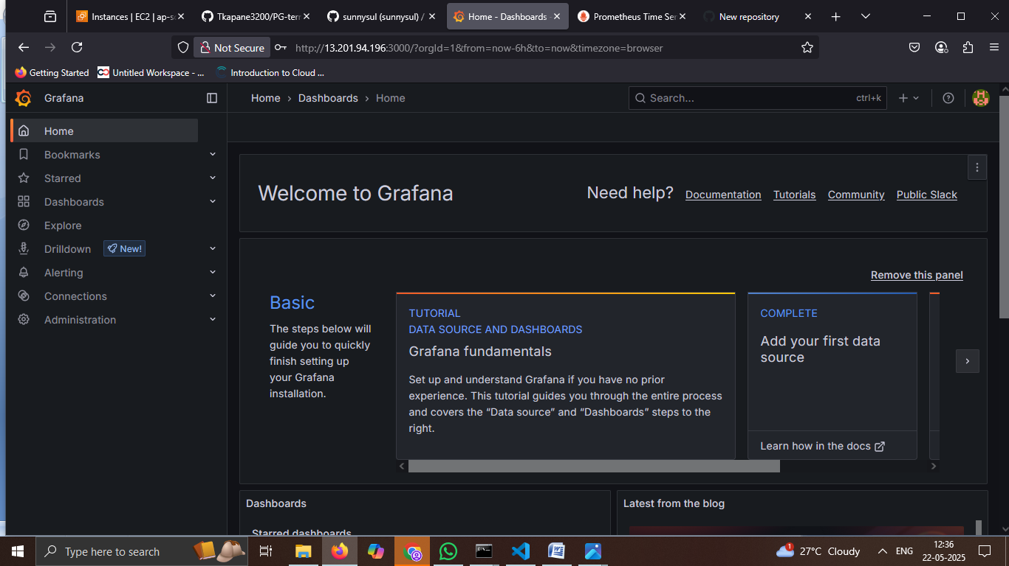

Task4).Kubernetes Assignment: Deploying and Managing Containers with Kubernetes (local)

Scenario: You are a DevOps engineer at "ABVC Solutions," a cloud-based software company. Your company wants to migrate its applications to Kubernetes for better scalability and management. Your task is to set up a Kubernetes cluster and deploy a sample microservices application.

Assignment Tasks:

• **Kubernetes Setup**

• Set up a Kubernetes cluster using a tool of your choice (e.g., Minikube for local development, or use cloud-managed Kubernetes clusters like GKE, EKS, or AKS).

• Ensure that kubectl is properly configured and can communicate with your **cluster.**

**Containerization and Docker**

• Containerize a sample microservices application using Docker. You can use a sample application or create a simple one.

• Create Docker images for each microservice.

**Kubernetes Deployments**

• Define Kubernetes Deployment resources for your microservices in YAML files.

• Include specifications for the number of replicas, container images, ports, and environment variables.

• Apply the deployment files to create deployments for each microservice in your Kubernetes cluster.

**Service Discovery and Load Balancing**

• Create Kubernetes Service resources for your microservices.

• Ensure that services expose your microservices to the cluster and set up load balancing.

• Test the services to verify that they can discover and route traffic to the microservices correctly.

**Scaling**

• Configure Horizontal Pod Autoscaling for one of the microservices based on CPU utilization.

• Test the autoscaling behavior by generating load on the microservice.

**Storage and Data Persistence**

• Set up a Kubernetes Persistent Volume and Persistent Volume Claim for your application.

• Modify one of the microservices to use the persistent volume for data storage.

• Demonstrate data persistence by creating, reading, and updating data within the microservice.

Step1: Install Kubernetes.

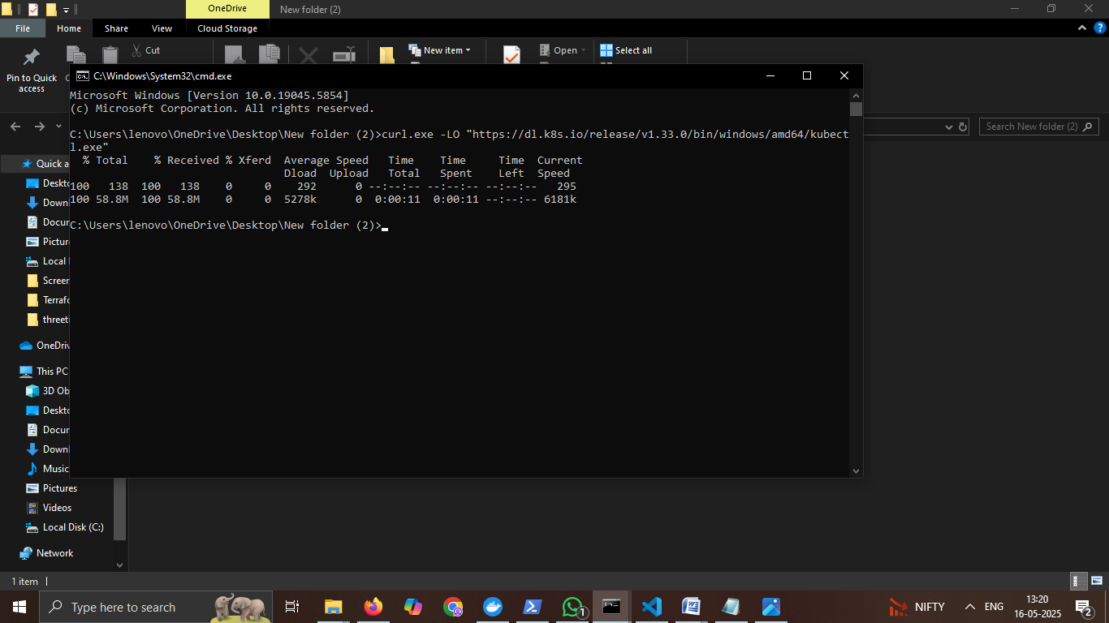

Step2: Install Minikube.

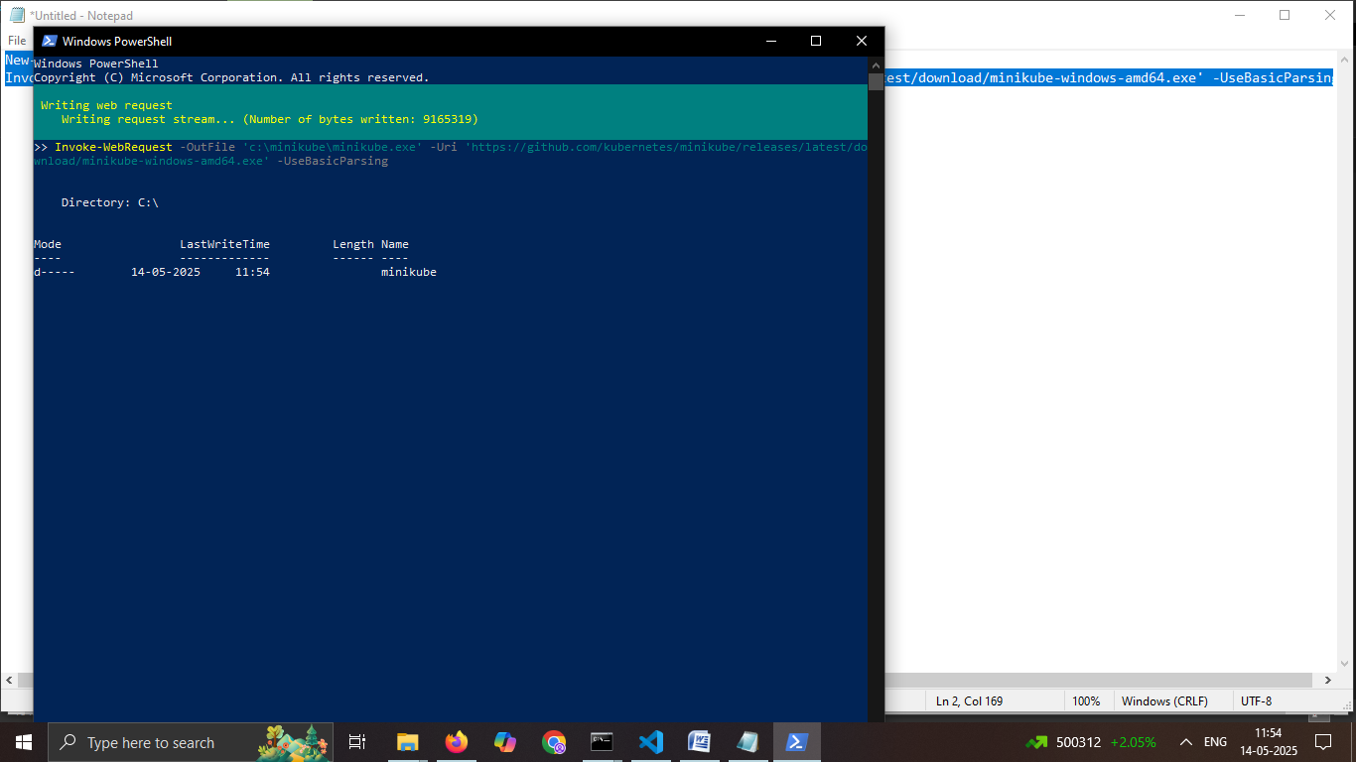

Step3: Install docker.

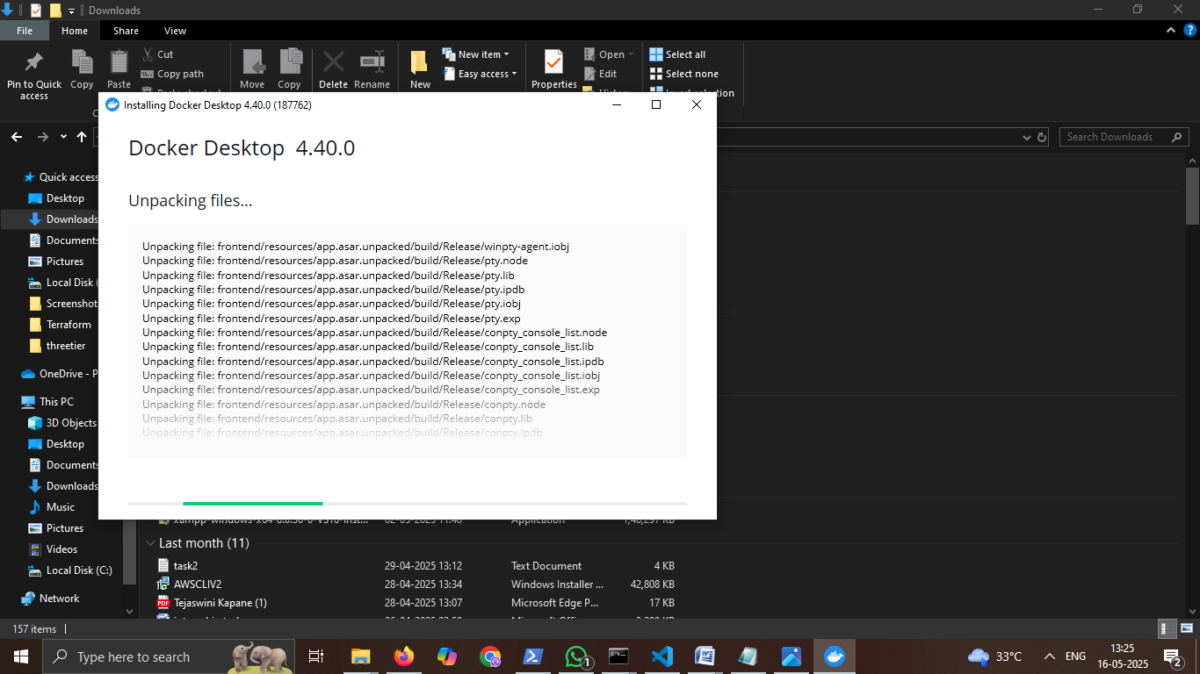

Step4: Build Two Services.

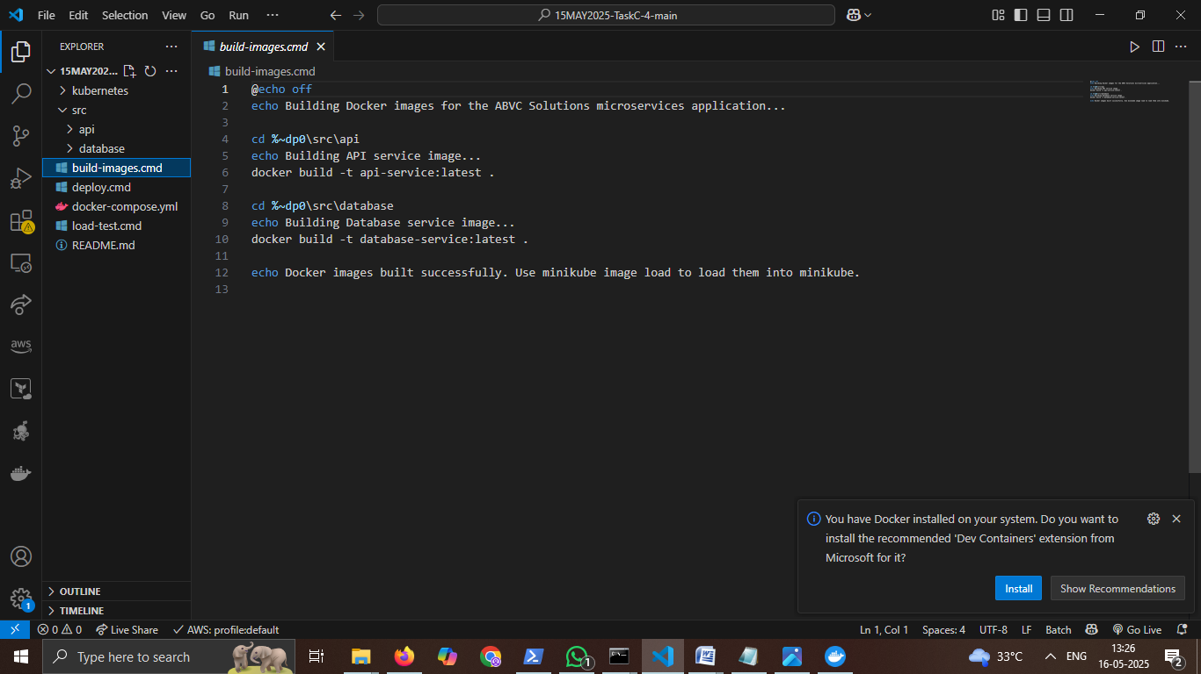

Step5: Start Minikube and Deploy Services.

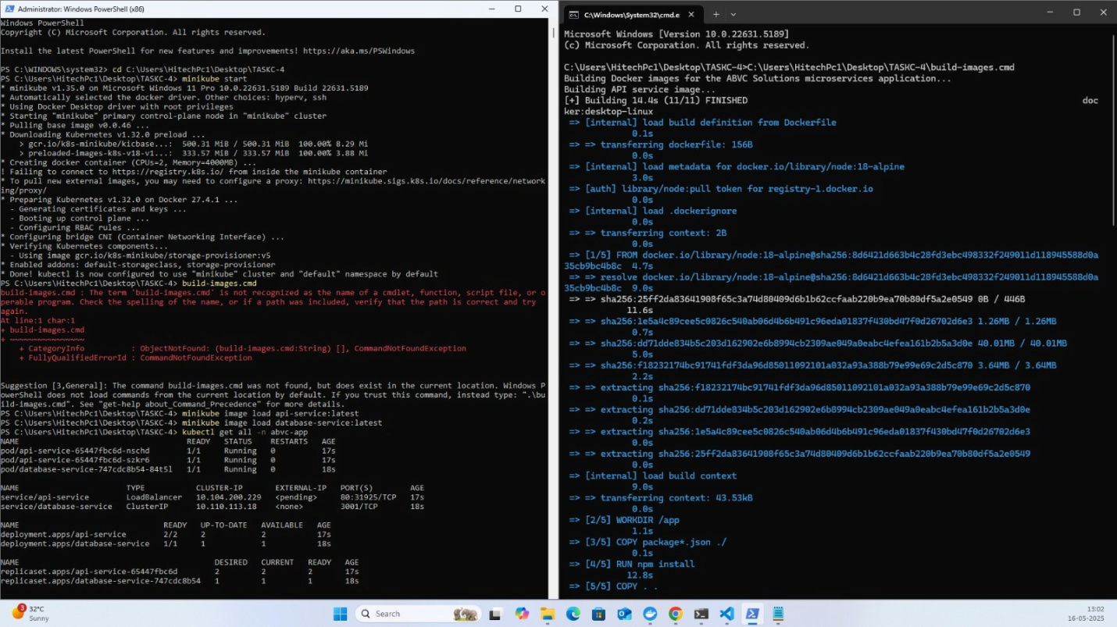

## **Summary of Commands Used.** ##

1. **start minikube**.

**#** minikube start

1. **Build Docker Images.**

# build-images.cmd

1. **Load Images into Minikube.**

# minikube image load api-service:latest

# minikube image load database-service:latest

1. **Deploy to Kubernetes.**

# deploy.cmd

1. **Verify Deployment**.

# kubectl get all -n abvc-app

1. **Access the Application.**

# minikube service api-service -n abvc-app –url

1. **Testing the Application.**

# curl -X POST -H "Content-Type: application/json" -d '{"name":"Test Item","description":"This is a test item"}' http://<service-url>/api/items

1. **Get All Items.**

# curl http://<service-url>/api/items

1. **Get Item by ID**.

# curl http://<service-url>/api/items/1

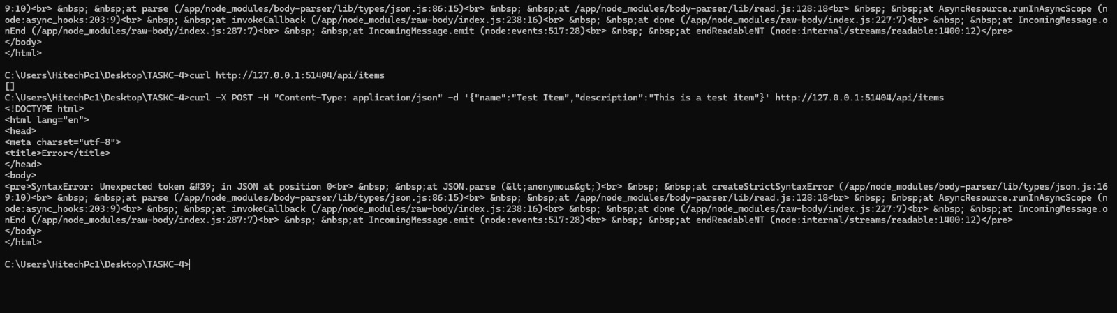

1. **Update Item.**

# curl -X PUT -H "Content-Type: application/json" -d '{"name":"Updated Item","description":"This is an updated item"}' http://<service-url>/api/items/1

1. **Delete Item.**

# curl -X DELETE http://<service-url>/api/items/1

1. **Test Data Persistence.**

# kubectl delete pod -n abvc-app -l app=database-service

1. **Test Autoscaling.**

# kubectl get hpa api-service-hpa -n abvc-app –watch

# hey -z 2m -c 50 http://<service-url>/api/items

1. **Cleanup.**

# kubectl delete namespace abvc-app

# kubectl delete pv data-pv

# minikube stop

EC2)

Step1) Update System and Install Docker Prerequisites on EC2.

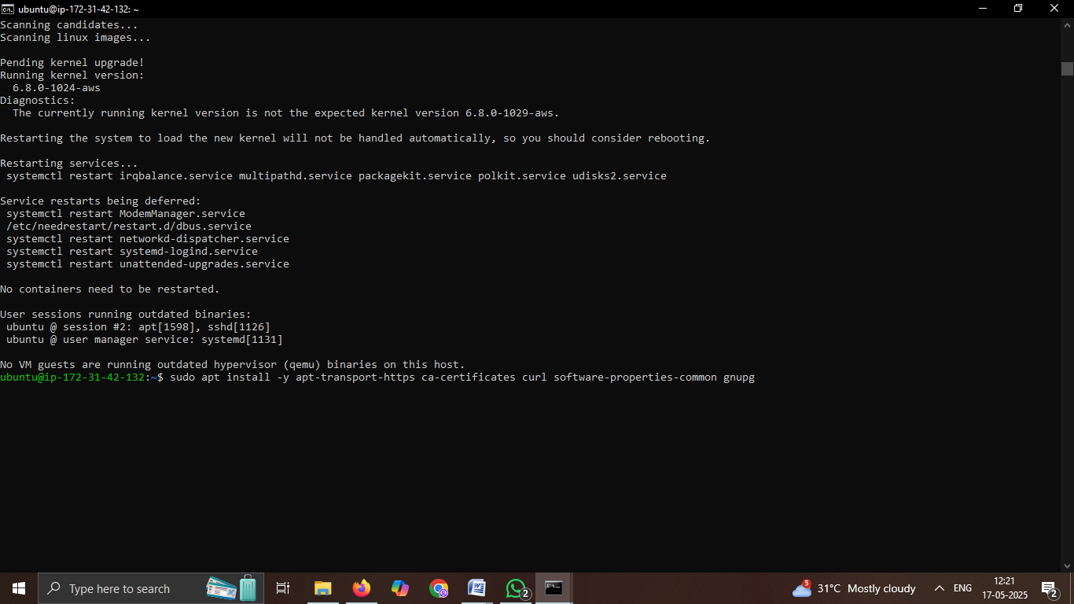

Step 2) Add Docker's official GPG key.

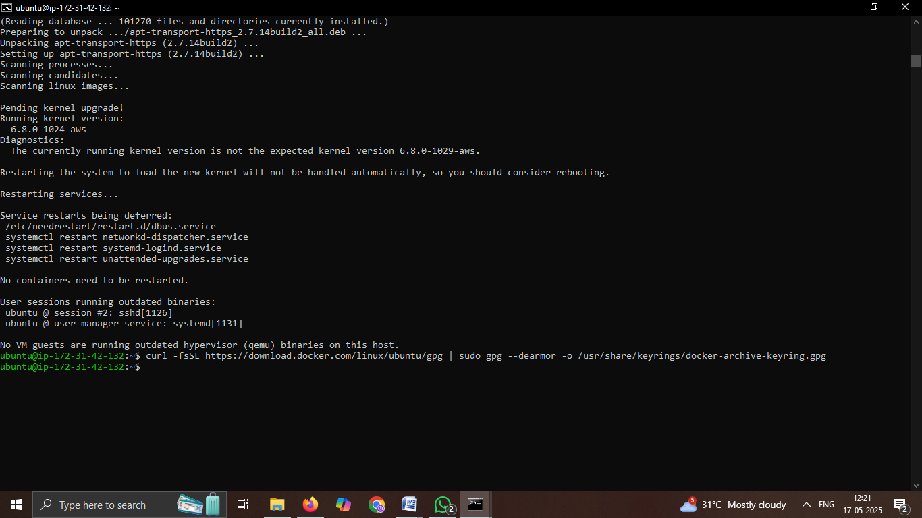

Step3) Set up Docker repository.

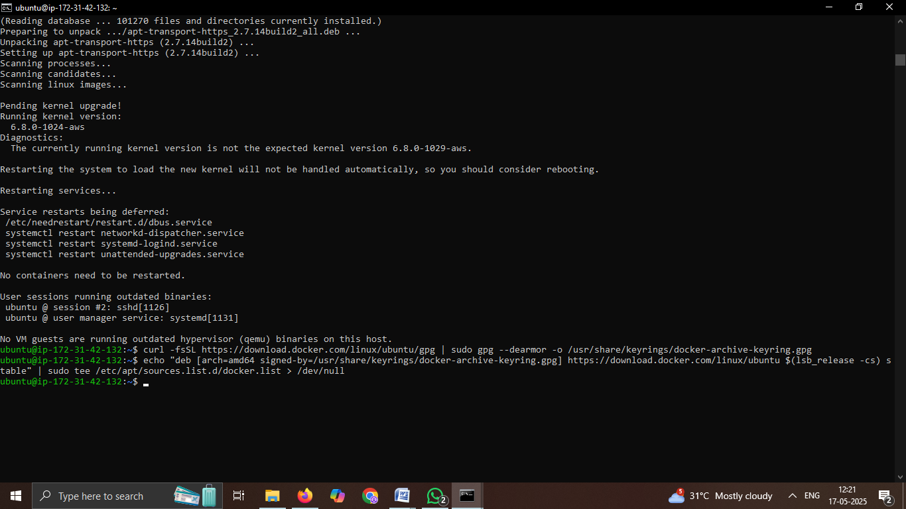

Step 4) Install Docker.

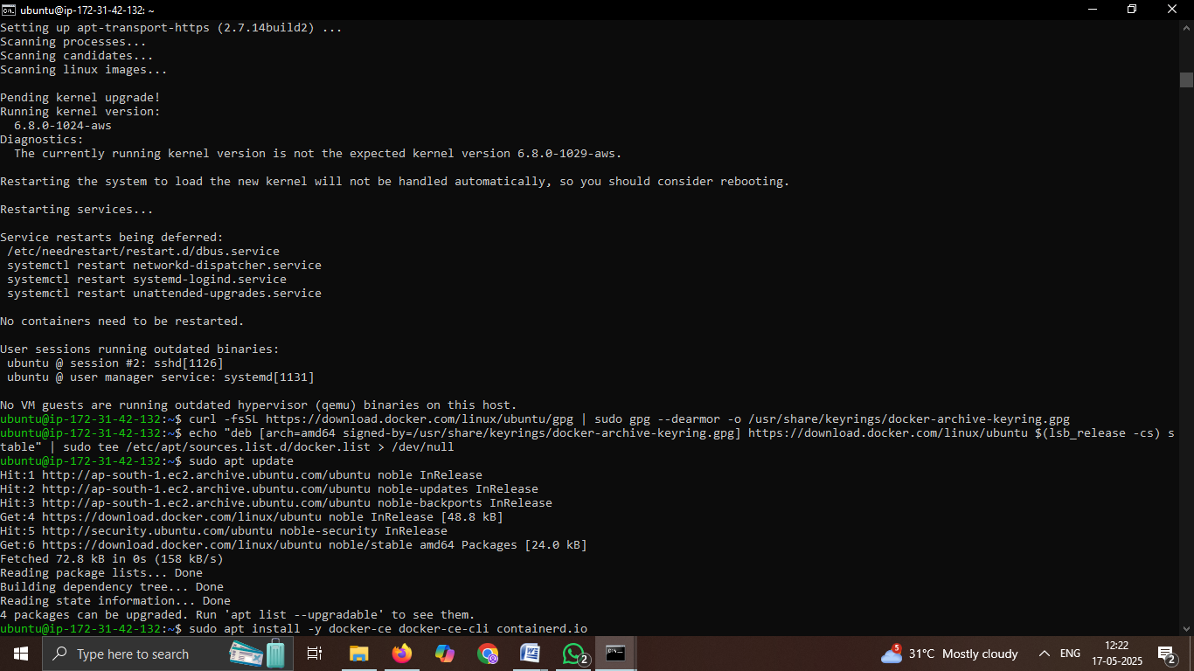

Step5) Add your user to the Docker group to run Docker commands without sudo.

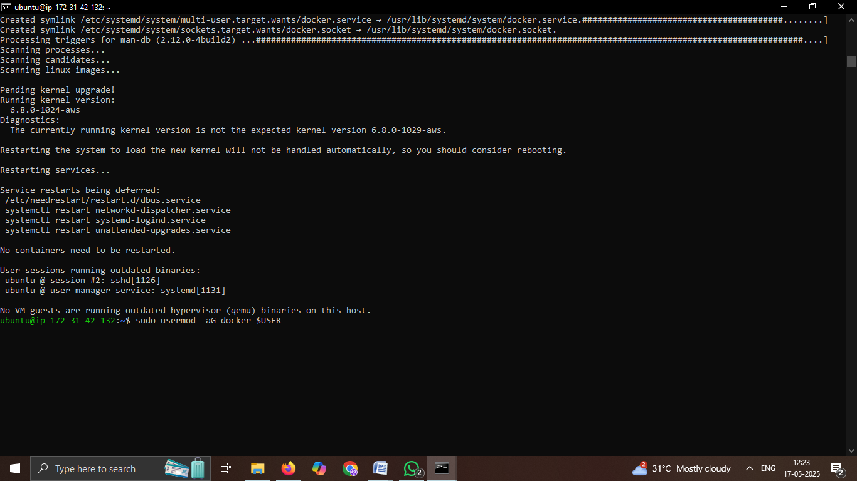

Step6) Start and enable Docker, Verify Docker installation.

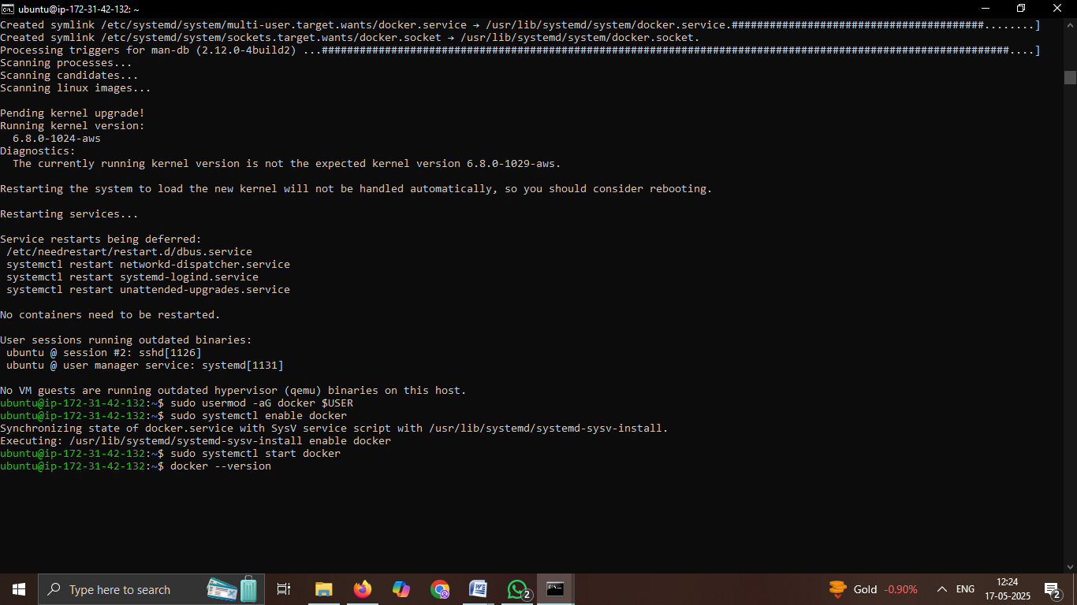

Step7) Download the kubectl binary.

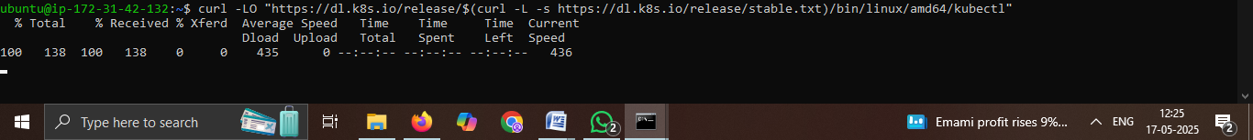

Step8) Install kubectl, Verify installation.

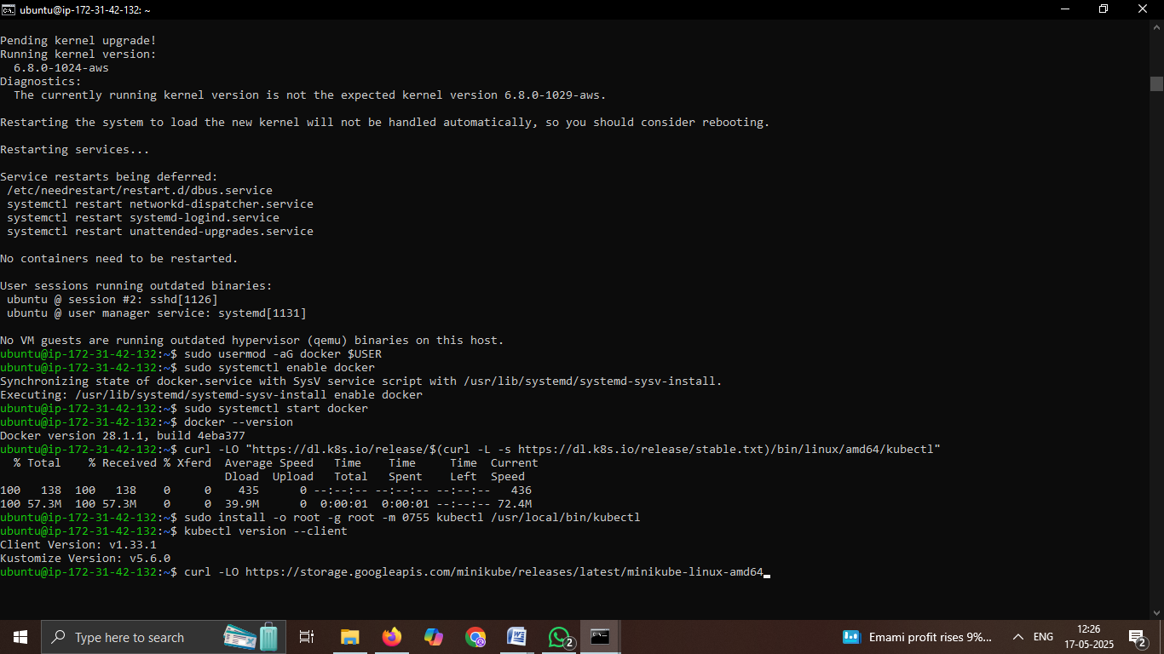

Step9) Download Minikube binary.



Step10) Install Minikube and Verify the Installation .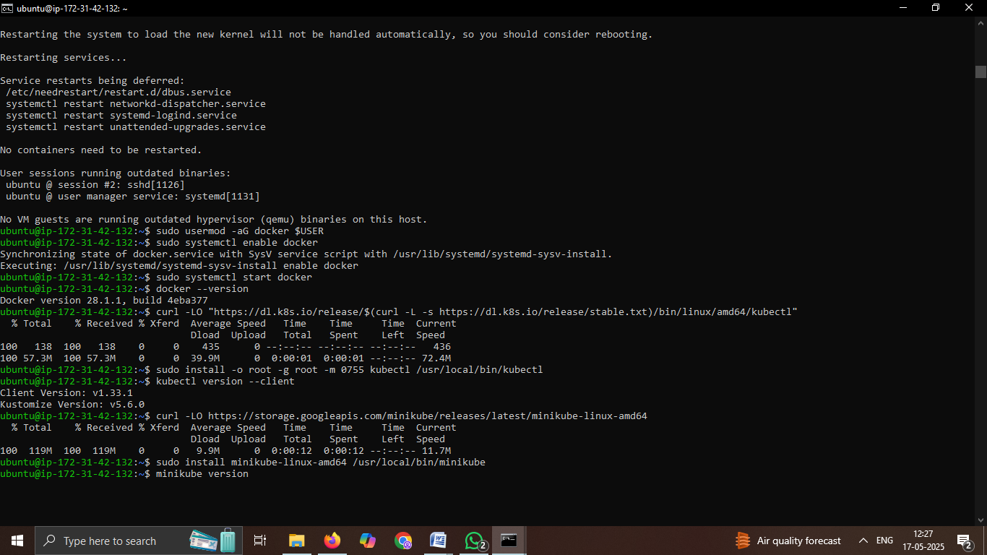

Step11) Install git.

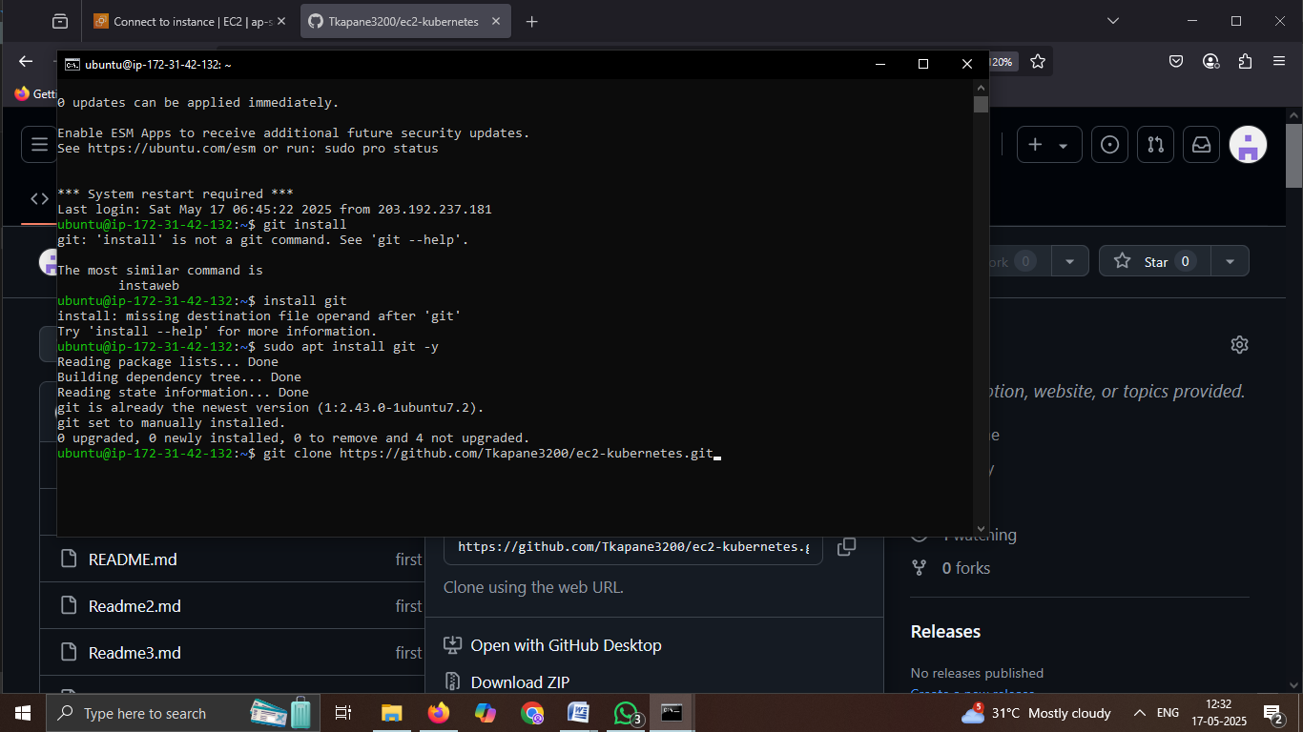

Step12) If you're cloning from a Git repository.

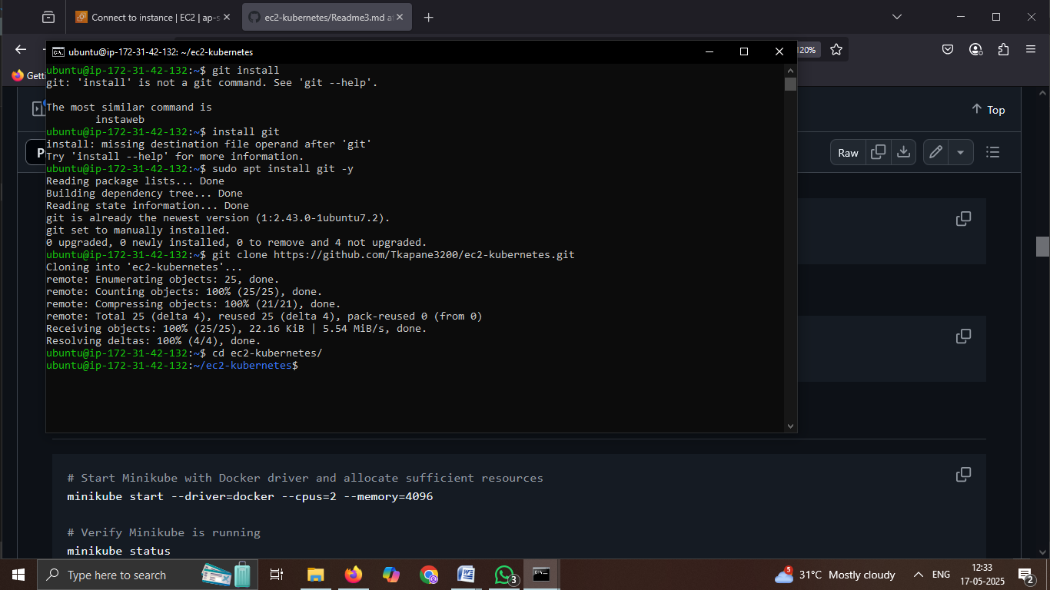

Step13) Start Minikube with Docker driver and allocate sufficient resources andVerify Minikube is running.

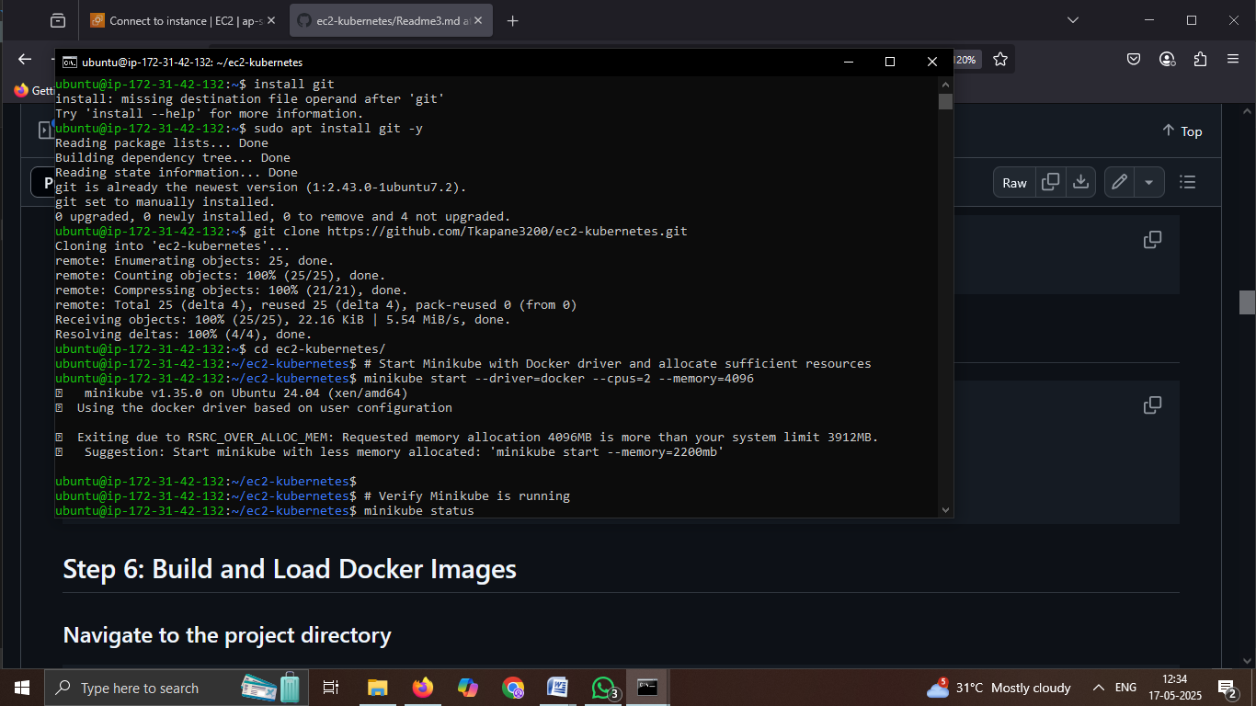

### Step14) Navigate to the project directory

#cd ~/ec2-kubernetes

Step15) Set the environment to use Minikube's Docker daemon and Build the API service image.

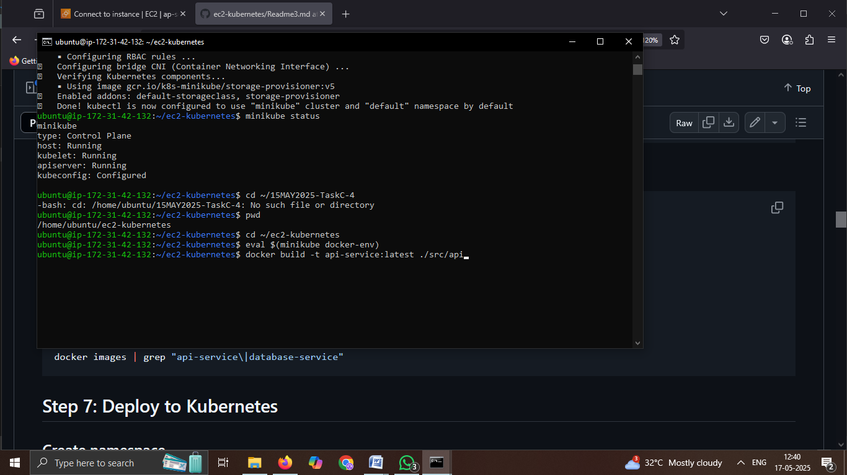

Step16) Build the Database service image.

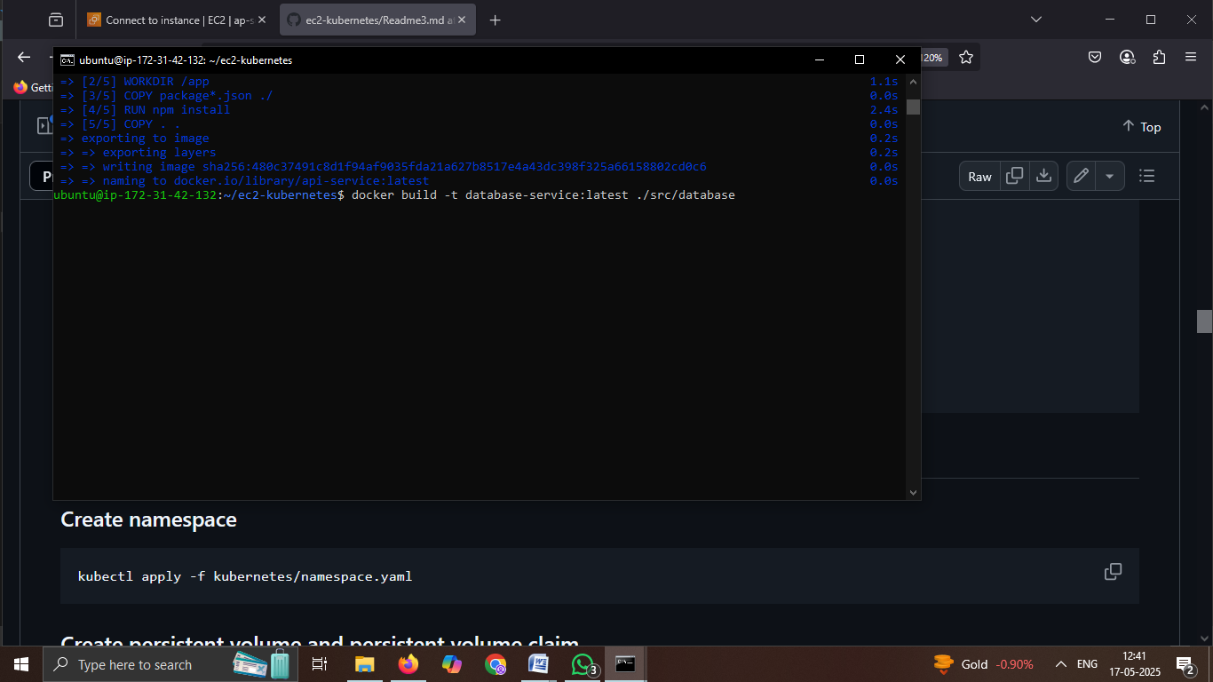

### Step17) Verify that images are built.

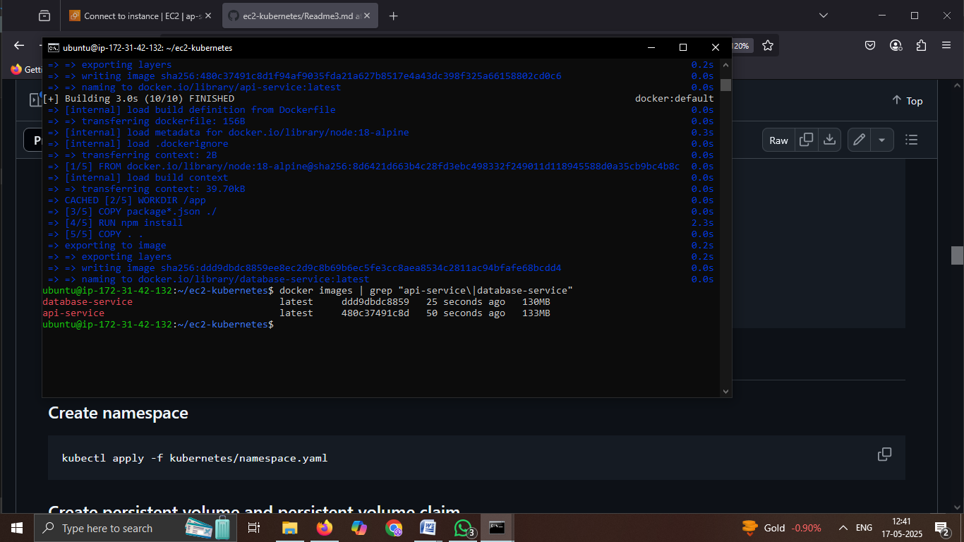

Step18) Set up Namespace, Persistent Volume and Claim, Deploy Services, Enable Autoscaling, and Verify Resources .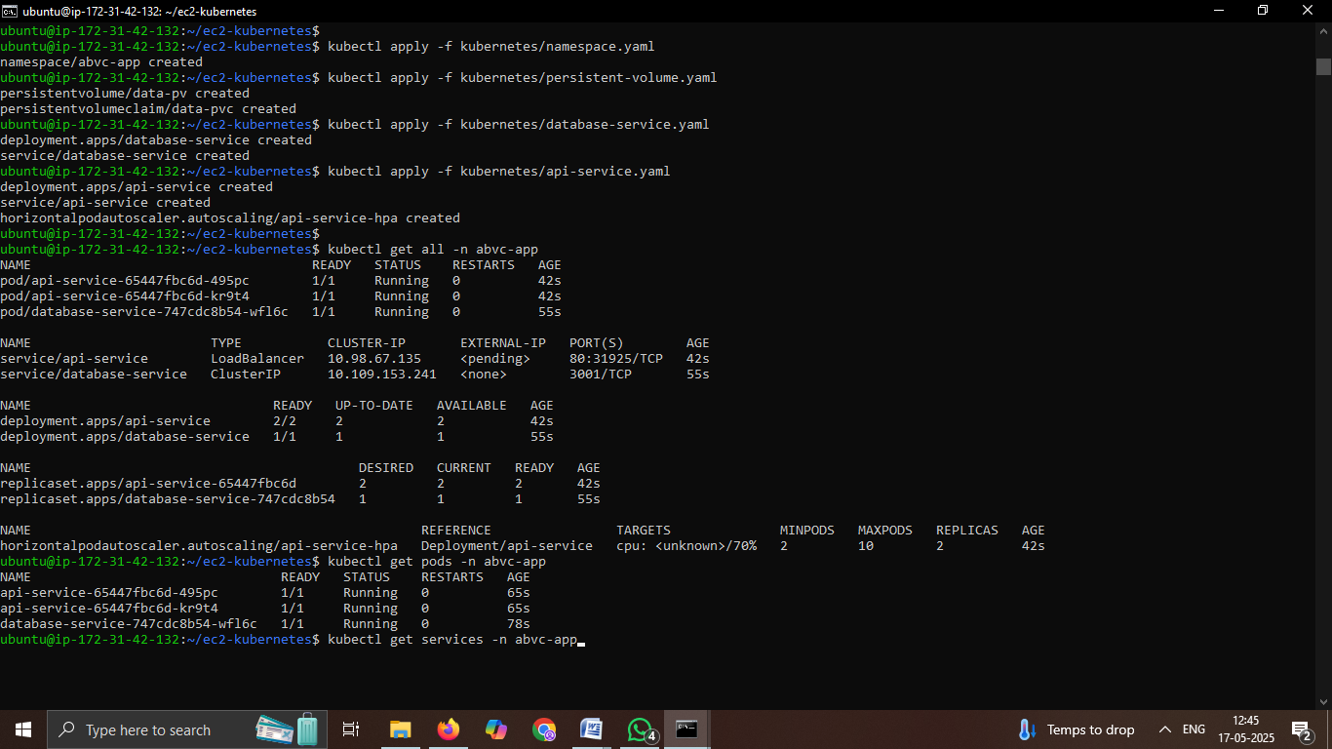

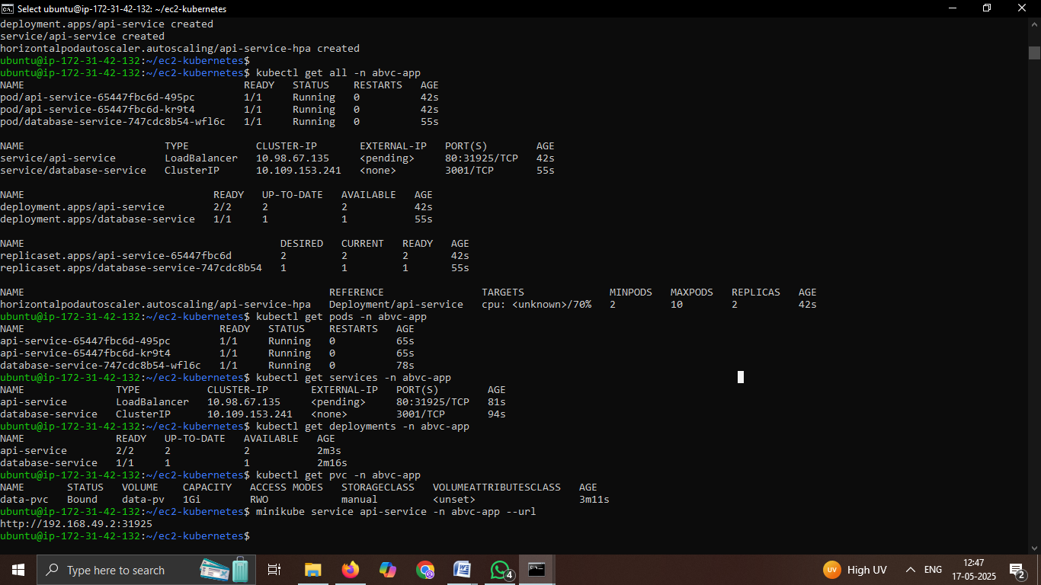

### Step19) Get the URL to access the API service.

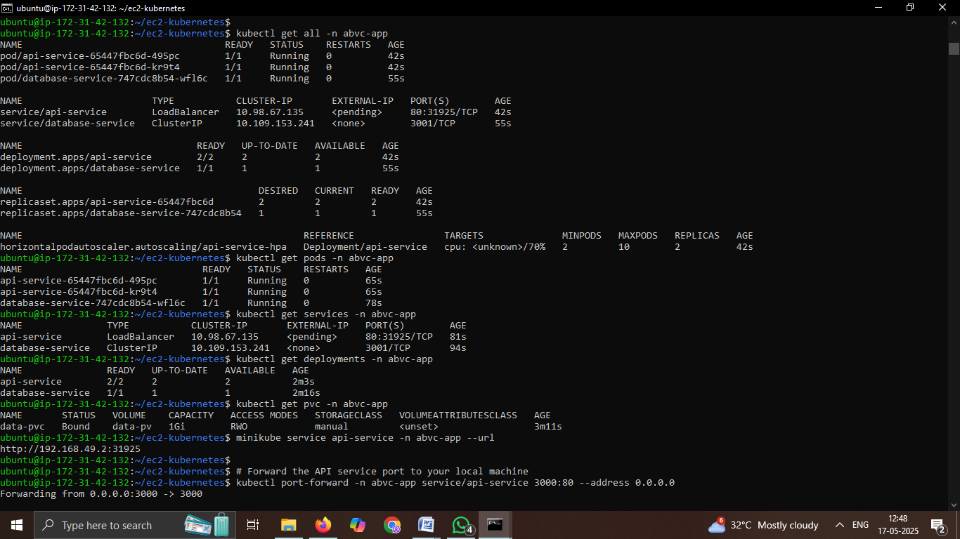

### Step20) Verify Application Health Endpoint Output.

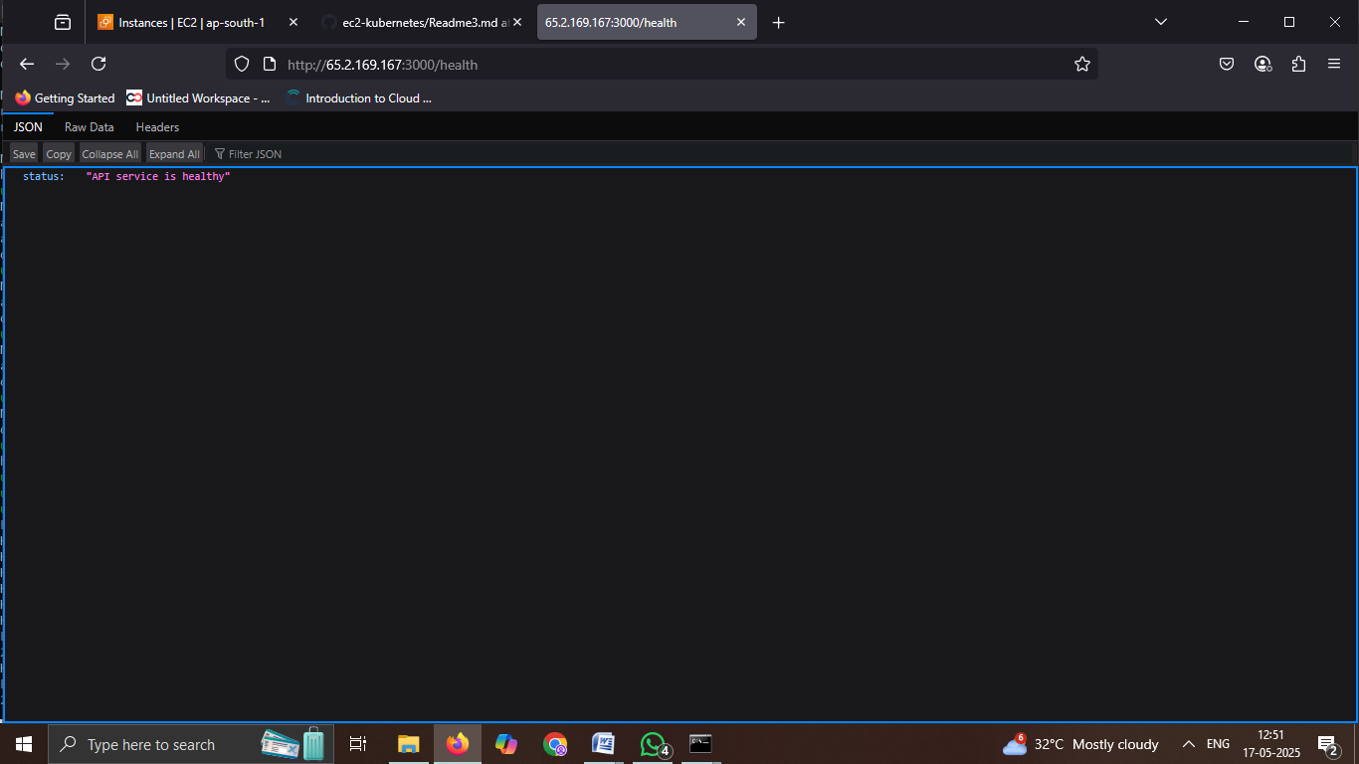

Step21) Successful GET request to /api/items endpoint in Postman, displaying a list of items with id, name, description, and createdAt fields in JSON forma.

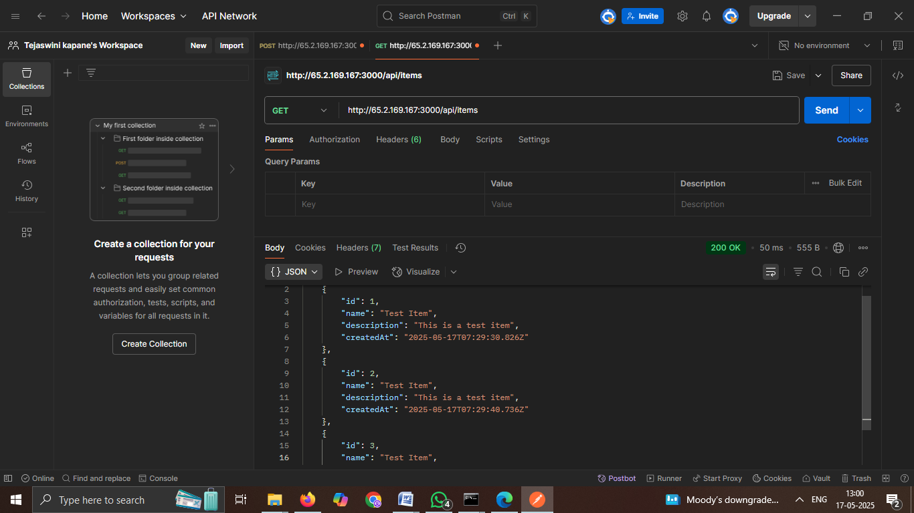

Step22) Port forwarding the api-service running in the abvc-app namespace to localhost on port 3000 using kubectl port-forward. Errors indicate connection reset by peer while attempting to forward traffic from the EC2 Kubernetes node to an external IP.

